Grade 3 - Art
Unit 1 - Line and Colour
September 9th - November 4th
(Approx. 7 classes)

Unit Projects

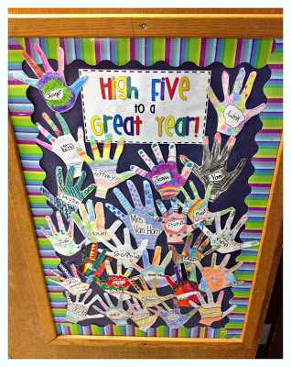
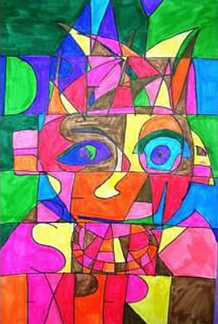
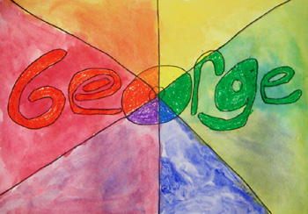

Colour Wheel Names
High Five to a Great Year!

Warm/Cool Stained Glass Portraits

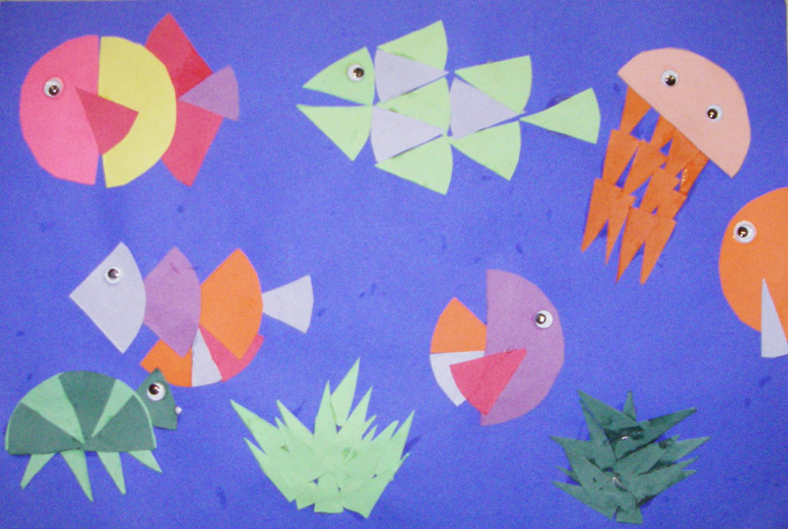
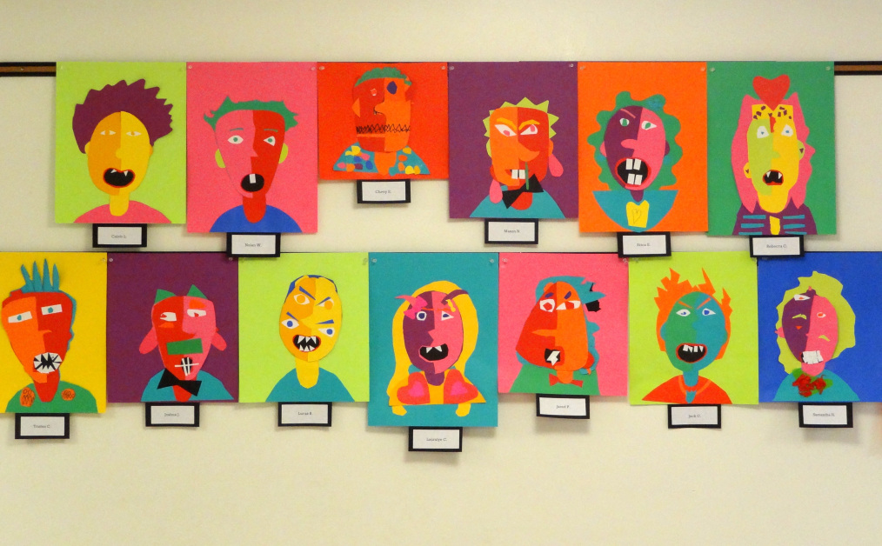

Colourful Faction Fish
Alter Ego Self Portraits

Unit Overview and Rationale

This unit focuses on the concepts of line and colour through the theme “All About Me.” This theme ties in with the “get to know each other” activities that take place at the beginning of the school year. Throughout this unit, the class will complete several art projects that allow the students to use line and colour while meeting outcomes from all four of the major components in the Alberta Art Program of Studies (Reflection, depiction, composition, and expression). The majority of the art projects will fall into the theme of this unit “All About Me,” as the students explore who they are through the opportunity to complete projects such as hand cut outs, self-portraits, and name art. Goals for the year will be tied in as students explore what they are able to do, what makes them unique and what they want to achieve.
The students will be able to complete each art project after appropriate scaffolding has been completed through a short lesson on the concepts needed for the completion of the project. Students will be given the tools they need to complete each project and a model or example photograph to give guidance or motivate them. The students will also be given visual and verbal instructions that will be chunked into snippets so that students are able to follow along with the class or move ahead based on their personal abilities. Each art project has been chosen carefully in that it follows with the unit concept of line and colour whilst focusing on learning about ourselves and each other to help build our positive classroom community!
Most of the learning within this unit will be hands on. Students will have the opportunity to listen to a short verbal lesson explaining new art concepts that are needed for the next task, be shown a model or photo of an example of the task, and be given verbal and written instructions on how to complete the task. The teacher or students will read aloud the instructions fully, as they will be posted on the SMART board for every task. The teacher will check for understanding through a formative assessment strategy such as having the students repeat each step of the task back or tell an elbow partner the task instructions. Students will then begin the task with teacher guidance leading them through the task step by step.
Students who are ahead will be encouraged to help their peers with the steps previous. In addition, the expectations for set up and clean up will be enforced strictly in every Art lesson to ensure time and safety are valued.
The theme of the unit ties with social studies objectives of studying community and belonging. The Fraction Fish project integrates math fractions practice, as students use their knowledge of fractions to create an underwater picture.

Learner Outcomes of Focus for the Unit
From Art Grades 1-6 (1985) Alberta Program of Studies
Level Two - Grades 3 & 4
REFLECTION - Grades 3 & 4
Component 1 - ANALYSIS: Students will make distinctions within classes of natural objects or forms.
Concepts
E. Change in natural form occurs over time
Component 2 - ASSESSMENT: Students will assess the visual qualities of objects.
Concepts
F. Surface treatments should harmonize with and not detract from the main form
Component 3 - APPRECIATION: Students will interpret artworks by examining their context and less visible characteristics.
Concepts
A. Contextual information (geographical, historical, biographical, cultural) may be needed to understand works of art.
D. Our associations influence the way we experience a work of art.
E. Art is valued for different reasons; e.g., aesthetic, economic, symbolic, associative
F. Art serves societal as well as personal needs.

DEPICTION - Grades 3 & 4
Component 4 - MAIN FORMS AND PROPORTIONS: Students will perfect forms and develop more realistic treatments.
Concepts
A.Shapes can suggest movement or stability.
B. Many shapes are symmetrical.
C. Images can be portrayed in varying degrees of realism.
D. Internal as well as external proportions can be depicted.
F. Size variations among objects give the illusion of depth.
Component 6 - QUALITIES AND DETAILS: Students will refine surface qualities of objects and forms.
Concepts
A. Texture can be represented from a range of different studio techniques.
B. Colour can be made to appear dull or bright.
C. Gradations of tone are useful to show depth or the effect of light on objects.
D. By increasing details in the foreground the illusion of depth and reality can be enhanced.

COMPOSITION - Grades 3 & 4
Component 7 - EMPHASIS: Students will create emphasis by the treatment of forms and qualities.
Concepts
A. The centre of interest can be made prominent by contrasting its size, shape, colour or texture from the other parts of the composition.
B. Format can be adjusted and composition tightened by editing or cropping the unnecessary areas from the edges of a work, after it is completed.
C. Details, accents and outlines will enhance the dominant area or thing.

Component 8 - UNITY: Students will create unity by interrelating the parts of a composition.
Concepts
A. The parts can be arranged so that movement in the picture space leads the eye around and not out of the picture area.
B. Parallel edges induce harmony within a composition.
C. Every major area of a composition should be interesting in itself.
D. Limited colours and materials tighten a composition.

Component 9 - CRAFTSMANSHIP: Students will improve compositions by refining, rehearsing and critiquing.
Concepts
A. Refinement of forms and surface qualities is necessary to give a finished appearance to a composition.

EXPRESSION - Grades 3 & 4
Component 10 (i) - PURPOSE 1: Students will record or document activities, people and discoveries.
Concepts
D. Knowledge gained from study or experimentation can be recorded visually.
Component 10 (i) - PURPOSE 2: Students will illustrate or tell a story.
Concepts
C. Material from any subject discipline can be illustrated visually.
Component 10 (i) - PURPOSE 3: Students will decorate items personally created.
Concepts
- Details, patterns or textures can be added to two-dimensional works.
Component 10 (i) - PURPOSE 4: Students will express a feeling or a message.
Concepts
- Feelings and moods can be interpreted visually.
Component 10 (i) - PURPOSE 5: Students will create an original composition, object or space based on supplied motivation.
Concepts
A. Outside stimulation from sources such as music, literature, photographs, film, creative movement, drama, television and computers can be interpreted visually.
D. Fantasy
E. People

Component 10 (iii) - MEDIA AND TECHNIQUES: Students will use media and techniques, with an emphasis on mixing media and perfecting techniques in drawing, painting, print making, sculpture, fabric arts, photography and techno graphic arts.
Concepts
- A. Drawing
  - Continue to explore ways of using drawing materials.
  - Use drawing tools to make a variety of lines extending beyond Level One into character and direction—passive, vertical, horizontal, diagonal, parallel.
  - Use drawing tools to make a variety of shapes and structures beyond Level One into symmetrical and asymmetrical, skeletal, spiral, and into mass drawing (blocking in the main parts of a composition).
  - Place more emphasis on direct observation as a basis for drawing.
  - Use drawing to add details, texture or to create pattern including drawing for high detail.
  - Make quick sketches.
  - Make drawings from a wide range of viewpoints.
  - Experiment with blind contour drawing and continuous line drawing.
  - Use drawing media to achieve gradations of tone or value in drawings.
  - Use simple methods to indicate depth or perspective; e.g., increase details in the foreground, use lighter tones or values in the background, large objects in foreground.
- B. Painting
  - Extend brush skills and further experimentation with the medium so as to achieve special effects such as textures.
  - Continue to paint, using experimental methods including without a brush.
  - Continue working with tempera paint or tempera paint with additives, and be introduced to watercolour.
  - Mix paints to show intensity of colour.
  - Continue to use paint in combination with other media and techniques.
  - Apply washes, using tempera or watercolour.
Use preliminary sketches as the basis for a painting, as well as painting directly.

Assessment Tools for Pre-Existing Knowledge

Different Lines and Colours - The theme for the unit is lines and colours, in order to understand and/or review what the students already understand about lines and colours we will use the elements as we create our art classroom rules and expectations. Students will be asked what they think an art classroom should look like and sound like. Together we will create a rules and expectations list on the whiteboard/chart paper. As students share their ideas they will be asked to write their “rule/expectation” in a warm colour/cool colour or in a complimentary colour based off of the last colour used. To separate our chart items we will use lines. The students will be asked to use different types of lines for this. This activity will serve as the pre-assessment for the unit’s elements, to see what knowledge the students already possess.

Lesson Sequence Plan Overview
May be Subject to Change
Approx. 7 blocks at 60 minutes each

Lesson 1: High Five to a Great Year!
Learning Outcomes/Key Questions and  Lesson Procedure (Activities) | Assessment/  Differentiation  and Modifications | Materials/  Technology | Resources
Learning Outcomes:  Reflection: Component 2-Assessment-Concept F  Depiction: Component 6-Concept A,B,C  Composition: Component 7-Concept A,C  Composition: Component 8-Concept C,D  Expression-Component 10(i) Purpose 3-Concept A  Expression- Component 10(i) Purpose 5-Concept A  Expression-Component 10(i) Concept A  Key Questions:  What should an art classroom look like?  What should an art classroom sound like?  Learning Activities:  Have own model already hanging on the classroom door in the middle.  Create an “Art Expectations” chart together as a class (clean up, assist, be kind etc)  Show students the model and analyze its details as a class. Discuss some items each student could include. Explain the instructions for the task.  - Trace out hand  - Write name in Sharpie in the name (must stay visible)  - Use different colours, patterns, lines, shapes, designs, and textures to decorate your hand  - Hang all the hands on the door | Assessment:  Formative assessment of students following “art expectations” chart, participating in the task, assisting each other in tracing, and putting effort into the task. Begin to mentally note the different abilities seen in the students.  Differentiation: Verbal and written instructions, chunking, students assisting each other with hand tracing and cutting, teacher one-on-one assistance, showing the model  Modifications:  The “Art Expectations” chart can be created as one individual class chart or the students can each make a smaller version of the chart. | Materials:  Sharpies, Markers/Pencils, Scissors, Cardstock  Technology:  SMART board | Resources: www.3rdgradethoughts.com

Lesson 2: Colour Wheel Names
Learning Outcomes/Key Questions and  Lesson Procedure (Activities) | Assessment/  Differentiation  And Modifications | Materials/  Technology | Resources
Learning Outcomes:  - Art:  Depiction: Component 4-Concepts B,F  Depiction: Component 6-Concepts A,B,C  Composition: Component 7-Concepts A,C  Composition: Component 8-Concepts A,B,C  Composition: Component 9- Concepts A  Expression: Component 10(i) Purpose 3-Concept A  Expression: Component 10(i) Purpose 4-Concept A  Expression: Component 10 (i) Purpose 5- Concept A  Expression: Component 10(iii) Concept A  Key Questions:  What is the order of the colour wheel?  What are the different gradients and tones of colour?  Learning Activities:  Read aloud: “The Name Jar” by Yangsook Choi  Review the colour wheel with the students, introduce gradients and tones of colour. Show students a model name tag and have them identify the different details shown such as the mixing of the watercolour to create colour, the gradients that are revealed, the depth depicted, the focus area, the unity of the art, light and dark tones in the name tag etc.  Have students practice using the watercolours on a blank piece of paper first. Show them the proper use of different brushes, and how to use the watercolours properly.  - Have students cursive/print their names in the center of the cardstock (practice on blank paper first!)  - Students will use a pencil (then a Sharpie) to separate their cardstock into 4-6 different segments to create their colour wheel using a ruler  - Begin to use the water colours to create their colour wheel name tag  Cut out and place on black paper if desired to make it pop | Assessment:  Observation for participation and effort, use of rulers to create straight/diagonal lines, color mixing, use of water colour to ensure enough instruction and direction is given on proper use  Differentiation:  Verbal and written instructions, review of colour wheel, introduction of vocabulary to help students understand different details they can include, chunking instructions, checking for understanding before we begin, having students assist each other, teacher one-on-one extra assistance, perhaps only divide into 2-3 segments to simplify task if needed, have a practice lesson on using water colors if needed  Modifications:  Use 2-3 segments instead of 4-6, have a lesson on practicing water colours before use on the name tags. | Materials:  Pencils, Sharpies, Cardstock, Rulers, Water colour paints, Paint brushes, Black construction paper  Technology:  SMART board | Resources: http://www.mrsbrownart.com/3rd.htm

Lesson 3: Warm/Cool Stained Glass Portraits
Learning Outcomes/Key Questions  Lesson Procedure (Activities) | Assessment/  Differentiation  And Modifications | Materials/  Technology | Resources
Learning Outcomes:  Reflection: Component 2-Assessment-Concept F  Reflection: Component 3-Appreciation-Concept D  Depiction: Component 4-Main Forms and Proportions-Concept B,C  Depiction: Component 6-Concept B  Composition: Component 7-Emphasis-Concept A  Composition: Component 8-Unity-Concept A  Expression-Component 10(i) Purpose 3-Concept A  Expression-Component 10(i) Purpose 4-Concept A  Expression- Component 10(i) Purpose 5-Concept A  Key Questions:  What are primary colours? What are secondary colours?  What is the difference between warm colours and cool colours?  What is unity and how can we create it in our artwork?  Learning Activities:  Review the terms “emphasis” and “proportion”  Introduce “unity” “warm colours” “cool colours”  Ensure students are aware that the whole page must be covered in colour.  - We review primary and secondary colors. Review/introduce (depending on my audience) warm and cool colors using PowerPoint slides.  - Guided drawing (our sloppy copy) to provide students with a framework bust portrait.  - Students re-draw their portrait in pencil on 11 inch x 18 inch white drawing paper.  - Students trace their portrait with black sharpie.  - Students are told to make 5-6 horizontal lines evenly across their paper.  - Each student is given a sticky note and asked to finish the sentence, “My dream is to be a. . .” We all share our answers with the class.  - Write the sentence in “all caps” across the horizontal lines on our papers. Trace with sharpie.  - Colour in lines with warm/cool colours. | Assessment:  Checklist with necessary items included for assessment use, checking for understanding, observation for participation and effort, following of instructions, mentally noting the different abilities in the classroom, following expectations, understanding of the use of the appropriate tools for the task.  Students will complete a peer feedback “art sandwich” handout on a partner’s artwork.  Differentiation: Verbal and written instructions, chunking, students assisting each other with the ruler tracing, teacher one-on-one assistance, showing the model and allowing time for brainstorming for the writing piece.  Modifications: If students have not completed sandwich feedback prior (or discussed the importance of clarity, specifics, and kindness in feedback), spend time discussing this in Art or in another subject area in which sandwich feedback may also be used. | Materials:  Sharpies, Markers/Pencils, Rulers, 11 inch x 18 inch white drawing paper  Technology:  SMART board, Warm Cool PowerPoint slides | Resources:  http://www.artfulartsyamy.com/2015/09/warmcool-stained-glass-portraits-in.html  http://www.mrsbrownart.com/3rd.htm  -Warm or Cool Shape Design

Lesson 4 and 5: Fraction Fish
Learning Outcomes/Key Questions  Lesson Procedure (Activities) | Assessment/  Differentiation  and Modifications | Materials/  Technology | Resources
Learning Outcomes:  Depiction: Component 4-Main Forms and Proportions-Concept A,B,F  Depiction: Component 6-Qualities and Details-Concept B  Composition: Component 7-Emphasis-Concept A  Expression-Component 10(i) Purpose 3-Concept A  Expression- Component 10(i) Purpose 5-Concept A  Expression-Component 10 (ii) - SUBJECT MATTER-Concept A  Expression-Component 10 (iii) - MEDIA AND TECHNIQUES  Key Questions:  How do I use scissors properly and safely?  What are examples of cool colours? What are examples of warm colours?  Learning Activities:  Use large circle cut-out to review fractions with students, such as whole, 1/2, 1/4, 1/8, 1/16. Have different students manipulate the circle to demonstrate various fractions.  - Have students use circle tracer to trace out and cut out 5 circles in different construction paper colors.  - Students will draw pencil lines of their fractions first before cutting. Partner check of their fraction circles before they cut.  - Tell students to:  Leave one as a whole.  Cut one circle in 1/2  Cut one circle in 1/4  Cut one circle in 1/8  The last one is your choice  - Students will use cut-outs to create fish, seaweed, and  under sea creatures from  your fractions. Challenge students to group warm and cool colours when making their fish.  - Students may cut-out more fractions to use.  After students finish their fraction fish, have them identify the fractions they used.  Read Rainbow Fish by Marcus Pfister aloud to students as they finish. | Assessment: Observation for participation and effort, staying on task, following instructions, and following art expectations, check final projects for fractions to be included  Differentiation: Assist students in drawing out their fractions on their circle cutouts. Analyze their fraction drawings for further assistance, chunking instructions, verbal and written instructions, brainstorming together, peer assistance with the partner check, teacher assistance  Modifications:  Extension of time, if needed  Integration:  This art project connects with math study of fractions, students will be creating fractions and identifying fractions | Materials:  12"x18" blue construction paper, assorted colored construction paper, pencils, circle tracers, Elmer's glue, googley eye  Technology:  SMART board, Fraction Fish PowerPoint slides | Resources:  http://www.mrsbrownart.com/3rd.htm

Lesson 6 and 7: Alter Ego Self Portraits
Learning Outcomes/Key Questions  Lesson Procedure (Activities) | Assessment/  Differentiation  and Modifications | Materials/  Technology | Resources
Learning Outcomes:  Reflection: Component 3-Appreciation-Concept D,E,F  Depiction: Component 4-Main Forms and Proportions-Concept A,B,C,F  Depiction: Component 6-Qualities and Details-Concept A,B  Composition: Component 7-Emphasis-Concept A,B  Composition: Component 8-Unity-Concept A,C,D  Expression-Component 10(i) Purpose 3-Concept A  Expression-Component 10(i) Purpose 4-Concept A  Expression- Component 10(i) Purpose 5-Concept A  Expression-Component 10 (iii) - MEDIA AND TECHNIQUES  Key Questions:  What does proportion mean?  What does expression mean?  How can we show proportion and expression in our artwork?  What are examples of complimentary colours?  How do I use scissors properly and safely?  Learning Activities:  Before, discuss the artwork of Abstract artist Pablo Picasso.  Review the colour wheel and terms “unity” “proportion” “expression”  Before starting look at Picasso’s painting "Girl Before a Mirror." Have students describe the various things they see (lines, shapes, colors, etc.). Discuss what they think the painting is supposed to be about. After, share the title of the painting.  Analyze the Picasso art to notice the way that the colour is used to emphasize certain areas more than others.  - Turn paper horizontal and drawing a face shape (using pencil) in the middle of our paper. The students draw a "profile" line going down the middle of the face, thereby making the face look like it was actually 2 faces-a profile view, and a front view.  Look back at work by Pablo Picasso, taking note of the different angles represented in his Cubist work, to lead into a conversation about showing different sides of ourselves. Ask students if they have a different version of themselves - explain that this is sometimes connected to emotions (Can show the book When Sofie Gets Really Really Angry). This alter ego can show the opposite side of your personality or a second self.  Connect back to Picassos portrait work and explain to students that they will be creating their own alter ego.  Provide brainstorming time. Students will then continue on their draft.  Introduce the concept of “complimentary colours” and tie the concept back to Picasso’s work. Have students use construction paper to  Identify a set of complimentary colours.  Show students a model of this art task.  Introduce and explain. Review instructions as a class.  - Add facial characteristics, eyes, extra nose, and mouths, emphasizing the use of SHAPES.  - The last part is to draw hair. Discuss the various types of lines that could be used to make hair.  - After students are done their draft alter ego they will create their alter ego using construction paper. Remind them to use complimentary colours.  Students may choose to name their alter ego. | Assessment: Checklist with necessary items included for assessment use, checking for understanding, observation for participation and effort, following of instructions, mentally noting the different abilities in the classroom, following expectations, understanding of the use of the appropriate tools for the task  Differentiation: Verbal and written instructions, chunking information, peer assistance, one-on-one teacher assistance, extra instructions, passing around the model, reviewing how to draw face characteristics, reviewing vocabulary, assistance using scissors  Modifications:  If there are time or ability considerations, the project can be completed using drawing and colouring rather than cutting and gluing  Integration:  This project could be included into Language Arts, students could write a story about their alter ego. | Materials: white paper, pencils/pencil crayons, coloured construction paper, scissors glue  Technology:  SMART Board | Resources:  Picasso's "Girl Before a Mirror,"  https://drydenartcity.wordpress.com/category/third/  http://www.incredibleart.org/lessons/elem/Jeanette-picasso.htm  http://www.incredibleart.org/lessons/elem/Jeanette-picasso.htm#sthash.HRq2uLT2.dpuf

Unit Handouts

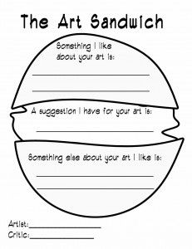

The Art Sandwich Peer Feedback
Fraction Fish Circle Cutouts

Literature Links:

The Name Jar, by Yangsook Choi
The Rainbow Fish, by Marcus Pfister
When Sofie Gets Angry - Really, Really, Angry, by Molly Bang

Technology Strategies
SMART Board

The SMART Board will be used in this unit to show students’ professional artist work that connects to the elements and/or projects that we will be working on. This will be helpful for the students to understand how the elements have been used and to show them the culture of art. The goal of showing students real artists work is to inspire them to find themselves as artists. The technology will allow the class to look at the artwork and enlarge the pieces to examine the art techniques.
For some of the projects, PowerPoint slides will be used to show students the steps for the project. This will be useful for students to refer back to the steps on the board as they work on their projects.

Assessment and Evaluation Tools
Unit Evaluation Criteria and Procedures

Observation as students complete each task - Students will be observed as they are working on their art projects. They will be watched to assess how they follow instructions and expectations and how they incorporate the art elements of the lesson into their project.
Checklists including necessary criteria - A checklist will be filled out by the teacher that includes criteria based off of the lesson objectives and art behavior expectations for two of the projects throughout the unit. These checklists are included below.
Checking for understanding - Before each art lesson we will review the art terms for the lesson of the day. After explaining the steps to the projects, the students will be asked questions on the project steps or will be asked to repeat the steps back to me to check for understanding.
Peer feedback - Students will complete a peer feedback “art sandwich” handout on a partner’s artwork. If students have not completed sandwich feedback prior (or discussed the importance of clarity, specifics, and kindness in feedback), spend time discussing this in Art or in another subject area in which sandwich feedback may also be used. This assessment will be used formatively, but will provide the students with the opportunity to assess peers work and to receive peer assessment.

Warm/Cool Stained Glass Portrait Criteria Checklist
Yes No
1. Did the student successfully show the difference between warm and cool colours in their portrait?
Did they show two different examples of warm colours and two different examples of cool colours in their portrait?
2. Did the student effectively use the elements and principles of design to create a strong portrait composition?
Does the composition show unity (does it flow together)?
3. Did the student gain and understanding of the unit elements by demonstrating various uses of lines and colour in their portrait?
Does their portrait contain two different examples of complementary colours and two different examples of lines?
4. Did the student follow instructions, use art materials in an appropriate and safe manner, and clean up after him or herself?
Alter Ego Self Portrait Criteria Checklist
Yes No
1. Did the student successfully show multiple views of the face - in the style of Picasso?
Did they show two different emotions in their portrait?
2. Did the student effectively use the elements and principles of design to create a strong composition of two faces/two personalities?
Does the composition show unity (does it flow together)?
3. Did the student gain and understanding of the work of Pablo Picasso by demonstrating various uses of lines and colour in their portrait?
Does their portrait contain two different examples of complementary colours and two different examples of lines?
4. Did the student follow instructions, use art materials in an appropriate and safe manner, and clean up after him or herself?
Checklist Assessments

Website Resources

- Alberta Art Program of Studies - https://education.alberta.ca/fine-arts-1-6/programs-of-study/
- www.3rdgradethoughts.com
- http://www.mrsbrownart.com/3rd.htm
- http://www.artfulartsyamy.com/2015/09/warmcool-stained-glass-portraits-in.html
- Warm or Cool Shape Design http://www.mrsbrownart.com/3rd.htm
- http://www.mrsbrownart.com/3rd.htm
- Picasso's "Girl Before a Mirror,"
- https://drydenartcity.wordpress.com/category/third/
- http://www.incredibleart.org/lessons/elem/Jeanette-picasso.htm
- http://www.incredibleart.org/lessons/elem/Jeanette-picasso.htm#sthash.HRq2uLT2.dpuf

