Grade 3 - Math
Part 1 - Patterns and Algebra
September 19th - October 6th
(3 weeks)

Unit Overview

The math program used by this class is called JUMP Math. The program breaks the Alberta Program of Studies math concepts into the following sections: Patterns and Algebra, Number Sense, Measurement, Statistics and Data Management and Geometry. The JUMP approach strives to integrate a variety of games, magic tricks, activities, extensions and enriched units based on the beauty and wonder of mathematics in the classroom for students to explore and as a means for practicing, applying and extending mathematical skills and concepts. (Jump Math, 2007) This program is helpful to use in a math class for both the students and the teacher, because it steadily builds on concepts. Students are able to become confident with their abilities to complete the math and the teacher is able to assess student understanding at every step and keep everyone involved and on task. During or after each lesson the students will have the opportunity to practice either guided or independent on the skills of the lesson. The student workbooks will be used as an assessment tool throughout the unit, along with challenge question activities, tasks and quizzes. At the end of the unit, the students may complete a unit test.

Rationale for the Unit

The first area of focus that we will tackle as a class will be patterns and algebra. Patterns are important to teach because mathematics is about recognizing, describing and working with numerical and non-numerical patterns. Patterns exist in all strands of this program of studies. Working with patterns enables students to make connections within and beyond mathematics. These skills contribute to students' interaction with, and understanding of, their environment. Patterns may be represented in concrete, visual or symbolic form. Students should develop fluency in moving from one representation to another. Students must learn to recognize, extend, create and use mathematical patterns. Patterns allow students to make predictions and justify their reasoning when solving routine and non-routine problems. Learning to work with patterns in the early grades helps students develop algebraic thinking, which is foundational for working with more abstract mathematics in higher grades. (Alberta Education, 2014) By starting with a unit on patterns it creates a basic foundation of knowledge that will be helpful as the students move onto more difficult concepts.

Learner Outcomes of Focus for the Unit
From Mathematics K to Grade 12 Alberta Program of Studies

Patterns and Relations
General Outcomes
- Patterns: Use patterns to describe the world and to solve problems.
Patterns
Specific Outcomes | Lessons that Address Outcomes
- Demonstrate an understanding of increasing patterns by:  - describing  - extending  - comparing  - creating  numerical (numbers to 1000) and non-numerical patterns using manipulatives, diagrams, sounds, and actions. [C, CN, PS, R, V] | 1,2, 3, 7, 10, 15-19
- Demonstrate an understanding of decreasing patterns by:  - describing  - extending  - comparing  - creating  numerical (numbers to 1000) and non-numerical patterns using manipulatives, diagrams, sounds and actions. [C, CN, PS, R, V] | 4–7, 15, 16
- Sort objects or numbers, using one or more than one attribute. [C, CN, R, V] | 8, 9

Assessment Tools For Pre-existing Knowledge

Count to 100 Circle - Prior knowledge required for the unit, involves students having the ability to count to 100. As a class we will gather in a circle. The first student in the circle will start by saying number one and then we will go clockwise from student to student counting as a group to 100. For a challenge we can change directions and count down. This activity will be used to gage the students’ abilities to count to 100. If the students require additional practice, they will practice by filling in a hundreds chart.

What is a Pattern - To review previous knowledge of patterns and to establish a class understanding to what a pattern is, the students will be asked to pick out patterns from a list or set of objects. In their own words, they will come up with a definition of a pattern. Together as a class we will discuss their definitions and use them to create a class definition for what a pattern is. Afterwards they will have to create their own patterns using the objects and explain to a partner.

Using Your Hands - Before students can create or recognize a pattern in a sequence of numbers, they must be able to tell how far apart the successive terms in a particular sequence are. There is no point in introducing students to sequences if they don’t know how to find the gap between a given pair of numbers, either by applying their knowledge of basic addition and subtraction, or by counting on their fingers as described below. For weaker students, the following method will be used for recognizing gaps:
How far apart are 8 and 11?
STEP 1:
Say the lower number (“8”) with your fist closed.
STEP 2:
Count up by ones, raising your thumb first, then one finger at a time until you have reached
the higher number (11).
STEP 3:
The number of fingers you have up when you reach the final number is the answer
(in this case you have three fingers up, so three is the difference between 8 and 11.)
Using this method above, the weakest student will be taught to find the difference between two numbers in one lesson. Eventually, these students will be weaned off using their fingers to find the gap between a pair of numbers.

Lesson Sequence Plan Overview
May be Subject to Change
Approx. 24 blocks at 30 minutes each

Lesson # | Lesson Procedure  (Main Learning Activities)  Key Vocabulary  Key Questions  Learning Activities  Technology and Supplies | Differentiation/ Modifications | Assessment/Evaluation  FOR - Pre-assessments for students to learn  AS - assessment as students are learning  OF - assessment of students learning
1 | PA3-1 Counting  Students will find the differences between numbers mentally, by using fingers or by using a number line.  Key Vocabulary:  Difference, number line  Key Questions:  How can I find the difference between a set of numbers?  What is the difference between a set of numbers?  Learning Activities:  - Introduce the topic of number sequences. Provide an example.  - Ask students to interpret the pattern.  - Check to see if the students are able to find the difference between two numbers.  - Show students how to find the difference between two numbers using their hands.  - Sample questions with the whole class to discuss and solve.  - Worksheet questions and Go Fish Game Activity in pairs.  Technology and Supplies:  SMART board, Whiteboard, Student workbooks | Differentiation:  Show students how to use the fist counting method to help weaker students find the difference between numbers in a sequence.  Before assigning worksheet questions, the class will discuss and solve questions together. Sample questions will be given for students to work on independently before they move on to the worksheet.  Modifications:  If students are struggling with the concepts, more sample questions can be done with the whole class. | Have students provide interpretations of different patterns and explain. (FOR)  Use the class discussion to observe the students abilities. (AS)  Provide sample questions for the students to work on independently as an assessment to gauge if the students are ready to do the work on the worksheet. (FOR, OF)
2 | PA3-2 Preparation for Increasing Sequences  Students will find a number that is more than another number using a given difference.  Key Vocabulary:  Difference  Key Questions:  If I know the difference, how can I find a number that is more than another number?  Learning Activities:  - Warm up with adding practice.  - Do assessment sample questions with the class. Solve and discuss.  Technology and Supplies:  SMART board and Whiteboard, Student workbooks | Differentiation:  Warm up with students breaks the material into steps.  Help weaker students with material while the students work on the bonus question.  Modifications:  Students that have completed the bonus questions can split into pairs and continue the Go Fish Game from last class. | Formative assessment while students work on questions. (AS)  Begin to make mental notes of students’ abilities. (FOR)  Check for understanding and provide extra explanation for students that are struggling. (AS)
3 | PA3-3 Increasing Sequences  Students will extend increasing sequences and solve simple problems using increasing sequences.  Key Vocabulary:  difference, increasing sequence, pattern, number line  Key Questions:  How can I use an increasing sequence to solve problems?  Learning Activities:  - Students will identify the gap between successive pairs.  - They will say the last number in the sequence with their fist closed.  - They will continue adding terms to extend the sequence.  - Provide more difficult sequences for the students to solve.  - Use the increasing sequences in word problems.  Technology and Supplies:  Whiteboard | Differentiation:  Weaker students can use their fingers to extend the patterns.  Move through the steps at a pace that fits for the students.  Extra time can be spent on steps that the students are struggling with. | Have students point to a gap between successive pairs. (FOR)  Observation for participation and effort, following of instructions, mentally noting the different abilities in the classroom, following expectations, ask questions to check for understanding. (FOR, AS)  Students will solve a word problem using increasing sequences and share their solution. (OF)
4 | PA3-4 Counting Backwards  Students will find the difference between two numbers counting backwards-using fingers and a number line.  Key Vocabulary:  Difference  Key Questions:  How can I use counting backwards to find the difference between two numbers?  Learning Activities:  - Introduce topic with a riddle. Explain that you can use a number line to find a difference. Show a couple of examples on the board, using volunteers.  - Next have students brainstorm how they could solve a problem without a number line.  - Draw a number line on the board to show how to count backward and forward and relate it to adding and subtracting.  Technology and Supplies:  Whiteboard, SMART board | Differentiation:  Spend extra time with students who need more practice finding the gap between pairs of numbers by subtracting or counting backwards.  Modifications:  Can use flash cards to help students with adding and subtracting principles. | Observation for abilities, staying on task, following instructions, and following work expectations. (FOR, AS)  Check understanding using an assessment question that has students finding the difference between two numbers counting backwards. (OF)
5 | PA3-5 Preparation for Decreasing Sequences  Students will find the number that is less than the other number using a given difference.  Key Vocabulary:  Difference  Key Questions:  If I know the difference, how can I find a number that is less than another number?  Learning Activities:  - Warm up with adding practice.  - Do assessment sample questions with the class. Solve and discuss.  - Have the students come up with word problems in pairs using a given difference to solve.  Technology and Supplies:  SMART board and Whiteboard, Student workbooks | Differentiation:  Warm up with students breaks the material into steps.  Use real-life examples for the students to practice with or objects that the students can manipulate.  Modifications:  Help weaker students with material while the students work on the bonus question. | Formative assessment while students work on questions. Begin to make mental notes of students’ abilities. (FOR, AS)  Check for understanding and provide extra explanation for students that are struggling. (AS)  Students will independently solve a sample question and share the answer. (OF)  Students will create a word problem. (OF)
6 | PA3-6 Decreasing Sequences  Students will find the differences between two numbers by subtraction, and extending decreasing sequences.  Key Vocabulary:  difference, decreasing sequence, pattern  Key Question:  How can I find the difference between two numbers?  Learning Activities:  - Remind students what an increasing sequence is.  - Provide an example of a decreasing sequence.  - Work through an example together as a warm up exercise.  - Have students work independently on an assessment question extending the decreasing sequences.  - With extra time the students can play A Game for Two Activity.  Technology and Supplies:  SMART board, two dice, hundreds chart | Differentiation:  Verbal and written instructions, chunking information, peer assistance, one-on-one teacher assistance, extra instructions, reviewing steps  Modifications:  Instead of working independently on questions, if the most of the class is struggling than more questions can be done on the board, with solve and discuss. | Observation for participation and effort, following of instructions, mentally noting the different abilities in the classroom, following expectations. (FOR, AS)  Ask questions to check for understanding during whole group discussion. (AS)  Students will complete an assessment question extending the decreasing sequences. (OF)
7 | PA3-7 Increasing and Decreasing Sequences  Students will distinguish between increasing and decreasing sequences, and extend sequences.  Key Vocabulary:  Difference, increasing sequence, decreasing sequence, pattern  Key Questions:  How can I tell if a sequence is increasing or decreasing?  How do I extend that sequence?  Learning Activities:  - Remind students about how they can extend a sequence using the gap provided. Give examples for both increasing and decreasing sequences.  - Write several sentences on the board and ASK: Does the sequence increase or decrease? What sign should you use for the gap? Plus or minus? What is the difference between the numbers?  - Let students practice on the question and then extend the question.  - For assessment ask the students to extend the sequences.  Technology and Supplies:  Whiteboard, Student workbooks | Differentiation:  Peer assistance, teacher assistance, breaks the problem into steps.  Modifications:  Complete additional sequence problems with students that are struggling.  Extension activities for strong students. Word problems or “A Game For Pairs.” | Have students help provide examples on the board for increasing and decreasing sequences. (FOR)  Observe students as they practice on the questions and extend the question. (AS)  Ask students to extend the sequences. First they must identify the difference. Check to see if the students have the correct “gap.” (OF)
8 | PA3-8 Attributes  Students will distinguish the attributes that change in a sequence, and make sequences with the given number of changing attributes.  Key Vocabulary:  attribute, colour, shape, size  Key Questions:  What are attributes?  What attributes are changing in a sequence?  If I know what the number of attributes are that change, what sequences can I make?  Learning Activities:  - Draw two similar triangles on the board and ask students to describe the shapes. Add more shapes in different sizes and colours. Begin to create a table.  - Explain that properties are called “attributes” and write that word in the top left cell of the table.  - Provide time for students to practice in pairs saying the shape and listing two attributes. Give students several patterns and ask them to write the attribute that changes.  - A Game for Pairs or Groups Activity  Technology and Supplies:  Pattern blocks or beads, whiteboard | Differentiation:  Have students spend time drawing the shapes and giving them attributes to gain an understanding.  If students are having problems deciding which attributes change provide students with a limited list to choose from.  Use real objects to help show attributes.  Modifications:  Extension for strong students is to play the game “Which Doesn’t Belong.” | Have students name shapes. Have students describe the shapes and what makes them different from each other to check for student understanding. (FOR)  As students are practicing in pairs, walk around and observe/listen as they say the shape and attributes. (AS)  Students will write the attribute that changes in each pattern. (OF)
9 | PA3-9 Patterns Where Two Attributes Change  Students will distinguish the attributes that changed in a sequence, and make sequences where two attributes change.  Key Vocabulary:  attribute, shape, colour, size  Key Questions:  What attributes changed in a sequence?  How can I make sequences where two attributes change?  Learning Activities:  - Remind students what an attribute is an ask them to explain which attribute changes in an example problem.  - Ask students to name some attributes in a collection of objects, and to draw a sequence where at least one of the attributes changes.  - Give students several patterns where two attributes change and ask them to name the attribute that change.  - Activity: SET Game  Technology and Supplies:  SMART Board, White Board, SET Game, Necklaces or beads | Differentiation:  Verbal and written instructions, chunking information, peer assistance, one-on-one teacher assistance, extra instructions, reviewing steps  Modifications:  Spend more time having students work with attribute patterns, before moving on the to activity game. | Give students several patterns where two attributes change and ask them to name the attribute that change. (FOR, OF)  To check for understanding, have students write the attributes that changed in each pattern and explain how many attributes changed. (OF)
10 | PA3-10 Repeating Patterns  Students will find the core of the pattern and continue the repeating pattern.  Key Vocabulary:  attribute, length of core, core  Key Questions:  How can I find the core of the pattern?  How can I continue the repeating pattern?  Learning Activities:  - Explain that a pattern is repeating if it consists of a “core” of terms or figures repeating over and over. Show an example.  - Show a pattern and extend it. Ask students if they agree with the way it was extended. Give more difficult examples of sequences where the core starts and ends with the same symbol.  - Explain that the length of the core is the number of terms in its core. Ask volunteers to find the length of the core for the examples that have been drawn.  - Students will practice circling the core of the pattern and then continue the pattern.  Technology and Supplies:  Beads, Pattern blocks, SMART Board, White Board | Differentiation:  Spend more time on simpler problems if students are struggling. Work through problems on the board. Solve and discuss to break sown the steps. | Ask students if they agree with the way the pattern was extended, evaluate responses. (FOR, AS)  Have students find the length of the core on the board examples. (AS, OF)  Have students circle the core of the pattern and then continue the pattern. Students will identify the core length. (OF)
11 | PA3-11 Extending Repeating Patterns  Students will continue a repeating pattern given its core.  Key Vocabulary:  Attribute, core, length of core, repeating pattern  Key Questions:  How can I continue a repeating pattern if I know its core?  Learning Activities:  - Draw several groups of figures that are the cores of repeating patterns. Ask students to continue the patterns.  - To practice draw several cores and extend some of the patterns in a wrong way. Ask students to grade the work and then correct any mistakes.  - Students can then practice in pairs building the core of patterns and the number of attributes that change in the core. The other partner has to continue the pattern and name the attributes that changed in the core.  Technology and Supplies:  White board, dice colored beads or pattern blocks | Differentiation:  Review the vocabulary, teacher assistance, peer assistance.  Extra questions to build understanding.  Modifications:  Supplement activity for students to practice. | For a pre-assessment, have students continue the patterns of the cores on the board. (FOR)  Observe students can they grade the work and correct the core pattern mistakes. (AS)  For assessment students will check pattern sequences to see if they are extended in the correct way and if they are not, the student has to write the correct extension. (OF)
12 | PA3-12 Finding Cores in Patterns  Students will find cores of repeating patterns.  Key Vocabulary:  Attribute, core, length of core, repeating pattern  Key Questions:  Can I find the core of a repeating pattern?  Learning Activities:  - Show students how to recognize the core of a pattern. Draw a sequence of blocks with a simple repeating pattern. Draw a rectangle around a set of blocks in the sequence.  - Ask students to say how many blocks are enclosed in the rectangle.  - Ask students to check if the pattern inside the rectangle reoccurs exactly in the next three blocks of the sequence, in each sequent block of three, until they have reached the end of the sequence.  Technology and Supplies:  Whiteboard, coloured blocks | Differentiation:  Could also have students do this exercise with coloured blocks, separating the blocks into sets, rather than drawing rectangles around them.  Or draw several sequences on the board and circle some of them in the wrong way. Asking students to grade the work and correct the mistakes. | Ask which figures are certain shapes. (FOR)  Observe student responses as they say how many blocks are in each rectangle. Have them hold up the number on their fingers. (FOR, AS)  Ask students to circle the core of a pattern to check for understanding. (OF)
13, 14 | PA3-13 Making Patterns in Squares  PA3-14 Making Patterns With Squares Advanced  Students will make patterns with blocks and squares.  Key Vocabulary:  Attribute, core, length of core, repeating pattern  Key Questions:  How can I make patterns with blocks and squares?  Learning Activities:  - Lie out a couple of blocks and ask volunteers to add blocks in the positions. After that draw several simple shapes on the board and ask more volunteers to draw an extra block in each of the places marked by an arrow.  - After that draw several sequences of blocks, first adding only one block at a time, then two and or more blocks, and ask your students to identify which blocks were added each time.  Technology and Supplies:  Whiteboard, Blocks, Grid paper | Differentiation:  Teach strong students the terms “horizontal” “vertical” “column” “row” “right” and “left.” Ask them to use these words to describe the changes in a sample pattern sequence.  Modifications:  Have students build the sequences on the worksheet with blocks. | Observation for participation and effort, following of instructions, mentally noting the different abilities in the classroom, following expectations. (FOR, AS)  Have students draw extra blocks to the shape drawn to continue the pattern. (FOR, AS)  Ask questions to check for understanding: as I add blocks to the drawings, ask students to identify where the blocks were added. (AS)  Have students practice by shading two squares that were added to a figure. Have them draw the next figure in the pattern on grid paper. (OF)
15 | PA3-15 Extending a Pattern Using a Rule  Students will extend patterns using a verbal rule.  Key Vocabulary:  pattern rule  Key Questions:  How can I extend a pattern if I know its rule?  Learning Activities:  - Write a number sequence on the board.  - Draw circles for the differences.  - Ask the students if they could describe the sequence without simply listing the individual items.  - For a challenge students may work in pairs. One student will write an increasing sequence without showing their partner. Their partner has to reproduce the sequence but they are not allowed to give more than one term of their sequence. This will help them understand how to best describe a sequence.  - For practice give students sample questions to continue patterns and create patterns of their own.  - A game activity can be played for additional practice.  Technology and Supplies:  White board, die and a coin | Differentiation:  Have students work with smaller patterns to get used to extending, before moving on to more difficult patterns.  Use manipulative objects to create the patterns for students to better see the pattern rule.  Modifications:  To extend the learning, students can be provided with the rules and have to extend the sequences based on the rules. | Formative assessment while students work on questions. Begin to make mental notes of students’ abilities. (FOR, AS)  Have students describe the sequence without just listing the individual items. (AS)  Observe students as they practice and create patterns on their own. (AS)  To assess have students complete a couple sample questions that have them continuing patterns. (OF)
16 | PA3-16 Identifying Pattern Rules  Students will identify simple pattern rules.  Key Vocabulary:  Increasing sequence, decreasing sequence, term  Key Questions:  How can I find out what the rule of a pattern is?  Learning Activities:  - Tell students that the task for last class is going to be repeated today only harder. They will be provided with a sequence but they will not know what the rule is, they have to find it themselves.  - Give them an example on the board. Ask: Is it a decreasing or increasing sequence? What was added/subtracted?  - Together write the rule for a list of patterns. Tell a story and have the students figure out which sequence is right.  - Introduce the word “term” for a general member of a sequence.  - Use the students to form a sequence by standing in a line. Each student has to say what term they are. Ask each term in the sequence to do some task (i.e. jumping jacks)  - Work independently on additional practice questions.  Technology and Supplies:  Whiteboard, SMART board. | Differentiation:  Verbal and written instructions, chunking information, peer assistance, one-on-one teacher assistance, extra instructions, reviewing steps  Modifications:  Return to the material from last class and provide students with a pattern and its rule.  Have students practice slightly manipulating the pattern rule and work with them to change the pattern to fit their new rule. | Observation for participation and effort, following of instructions, mentally noting the different abilities in the classroom, following expectations. (FOR, AS)  Have each student say what term they are in the sequence line as a way of asking questions to check for understanding. (AS, OF)  Observe students work on practice problems, ask students to explain how they found the pattern rule for one of the questions they are working on. (AS, OF)
17 | PA3-17 Introduction to T-tables  The students will be able to create a T-table for growing block patterns and to identify rules of number patterns using T-tables.  Key Vocabulary:  T-table, growing pattern, chart, core, term  Key Questions:  Why use a t-table to document patterns and find their rules?  How can I create a t-table and use it to find pattern rules?  Learning Activities:  - Draw a sequence of castles on the board and tell students that the castles represent several stages of building of a castle made of blocks.  - Ask students to imagine that they want to keep track of the number of blocks they used in each stage of building. Introduce a t-table as a simple way of keeping track.  - Draw table on board and ask students to help fill it in.  - Ask students to describe how the numbers in the table change. Write the number that it changes by outside the table between each term.  - Ask students to make a rule for the pattern in the table. Point out that the table helps them see how many blocks they will need for each stage of the castle before they even build it.  - Draw another castle sequence and have students predict the gap in terms in the t-table. Have students help extend the table.  - After completing these exercises, give students a quiz with several questions from the worksheet.  Technology and Supplies:  Student workbooks, Building blocks, Whiteboard. | Differentiation:  Building blocks can be used instead of drawing on the board to help students better understand the concept.  Modifications:  Students can have more time to practice and can practice constructing a sequence of shapes that grow in a fixed way. | Formative assessment while students work on questions. Make mental notes of students’ abilities and progress. (FOR, AS)  Have students explain in their own thinking how the table can help predict how many blocks they might need later on. (FOR, AS)  Ask students to describe how the numbers in the table change. (AS)  Have students predict the gaps in terms in the t-table on the board and have them help extend the table on their own paper. Before going over it as a class. (AS, OF)  To assess have students complete a couple sample questions (quiz) that have them continuing t-table sequences. (OF)
18 | PA3-18 T-tables  Students will extend patterns using T-tables.  Key Vocabulary:  T-table, chart, term  Key Questions:  How can I use a t-table to extend a pattern?  Learning Activities:  - Draw several patterns on the board. Ask students to predict how many blocks are needed for the next figure in each pattern. Ask them how they made their prediction.  - Invite volunteers to draw t-tables for the pattern on the board. More volunteers will extend the tables and check the results by building the next figure in the pattern.  - To extend this, the blocks can have costs to them and students have to find the cost of each figure in the pattern.  Technology and Supplies:  Student workbooks, Whiteboard, Pattern blocks. | Differentiation:  Use pattern blocks to build figures instead of drawing on the board.  Students can practice by solving sequences that they might encounter in life. Give students several questions about recipes that they can solve with a double chart.  Modifications:  To extend this, the blocks can have costs to them and students have to find the cost of each figure in the pattern. | Ask students to each draw a t-table for a pattern you write on the board. As a review of last class concepts. (FOR)  Draw patterns on the board and ask students to predict how many blocks in the next figure, have them explain their thinking. (AS, OF)  Observe students as they practice drawing t-tables for the patterns and extend the patterns using their tables. (AS)  Students will shade blocks that were added to each figure to make the next figure in a pattern. To check for understanding ask students how many blocks will the 6th figure in each pattern have. (AS, OF)
19 | PA3-19 Problems and Puzzles (Final Review)  Learning Activities:  - Students will complete a worksheet for extra practice.  - Final review of material.  Technology and Supplies:  Student workbooks, Whiteboard. | Differentiation:  Verbal and written instructions, chunking information, peer assistance, one-on-one teacher assistance, extra instructions, reviewing steps  Modifications:  Additional practice questions can be provided for students that are struggling with particular concepts.  The pattern blocks and beads can be brought out for students to use to practice patterns and sequences. | Formative assessment while students work on questions. (FOR, AS)  Check for understanding and provide extra explanation for students that are struggling. (AS, FOR)
20 - 24 | These blocks will be used for make up classes or as extra time to work on difficult concepts. | Differentiation:  Students may use a reader or a EA to help them complete the test. | The unit test will take place in these blocks. (OF)

Unit Handouts

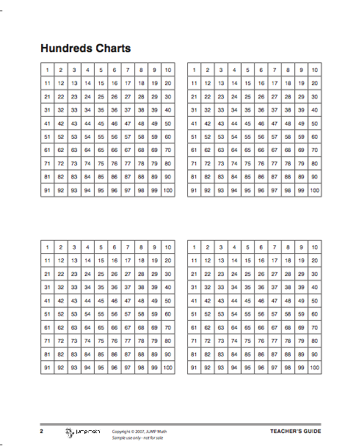
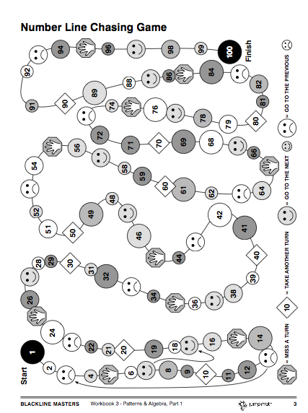

Technology Strategies
SMART Board
For every JUMP Math lesson plan there is a perfectly aligned interactive whiteboard file, complete with teacher prompts, sample questions, drawings, extensions, activities and bonus questions. Further, the JUMP Math SMART Lesson Materials integrate the many exciting and interactive tools and options inherent to this technology. Using interactive whiteboard-ready lesson materials based directly on the JUMP Math lesson plans will help reduce lesson preparation times, enabling teachers to devote more time and energy to reaching and teaching every child. (JUMP Math, 2007) While concrete manipulatives are still relevant for uses in classrooms, virtual manipulatives add to the learning experience. Virtual manipulatives give students prompts, feedback, and answers to problems while working on problems letting the students use more self-exploration.
The SMART board will be used throughout the unit, to help students visualize the patterns and sequences that we will be working with. The board will be used to bring up already built patterns and sequences for the class to analyze, solve and discuss. As a class we can manipulate the sequences, add to the patterns and draw new patterns. The board will be helpful to use because it will save teacher time spent on drawing/writing patterns and sequences, and also allow the students to easily move and add to problems that we are working on.

Virtual Manipulatives.com
Depending on access to computers and the students’ abilities, The National Library of Virtual Manipulatives technology will be used to help students explore building and creating their own patterns and sequences. This website contains various math manipulatives that students can click on and move around/rearrange. It would help students that require additional hands-on practice with patterns and students that may need that extra engagement of using the technology to work with the problems. As a class, we would use the website manipulatives such as the hundreds chart, pattern blocks or number line to solve a problem that I provide. Each student would use the technology to come up with the solution. Students could have the opportunity to use technology independently with a guided set of questions, while the larger group is working on a separate activity.

Assessment and Evaluation Tools
Unit Evaluation Criteria and Procedures

Student Workbooks - Student AP Books are used frequently as an assessment tool, for guided practice during the lesson or independent practice at the end of the lesson. In most lessons, however, the AP Books are only used after the teacher has led students through a graduated series of challenges or explorations. These are based on the questions in the AP Book or teachers manual, but might involve work with concrete materials, whole class or group discussions, or pencil and paper work on grid paper or in notebooks. Observation of students as they work through the books will take place. On a regular basis, the books will be flipped through to gauge a students progress. If certain students are observed to be struggling, then as the teacher I will take a look through their books to gain an understanding of what concepts need reinforcement and how to proceed with the learning activities.

Anecdotal Records and Observation Notes - During each lesson students will be observed for participation and effort in the lesson activities. In order to understand the concepts the students need to be actively involved in the discussions and questioning process of the lesson activities. I will observe their ability to follow instructions and meet general classroom expectations, such as listening and respectful participation. These expectations help create a positive classroom environment conductive to learning. During the first few lessons I will focus on mentally noting the different abilities in the classroom throughout the lessons and afterwards make notes on the observations. Student responses to questions and as they work independently on practice questions will be observed. These observation notes will be considered formative assessments of the students learning.

Challenges, questions and tasks - During or after most of the lessons, with an exception of a few, the students will complete a sample assessment question individually. The question will be based on the material covered in the day’s lesson. While students are working on the question, I will walk around and observe and make notes of the questions that the students ask when the need help. This will help me assess the students understanding of the material and help guide the learning that needs to happen next. Tasks and challenges that the students may work on in pairs will be used to evaluate student understanding also. The product that the students produce during the challenges/tasks will be used to assess the students’ abilities to explain their thinking to others and to solve problems collaboratively.

Quiz Question and Unit Test - The quiz question and the unit test will be used to summatively assess what the students have learned throughout the unit. The questions on the unit test summarize the key learning’s from the unit objectives.

Unit Test - Patterns and Algebra Part 1

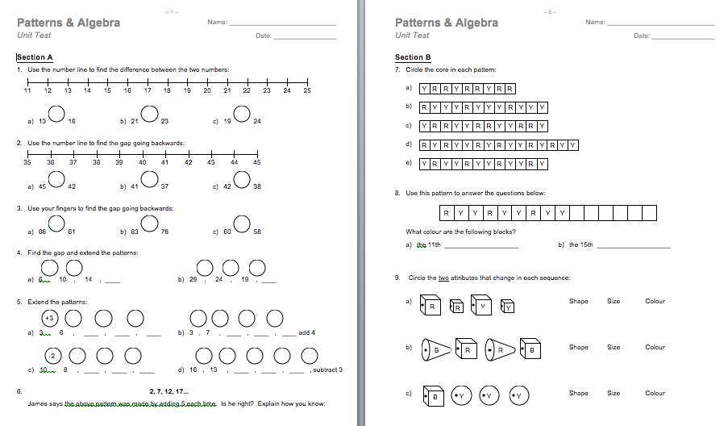

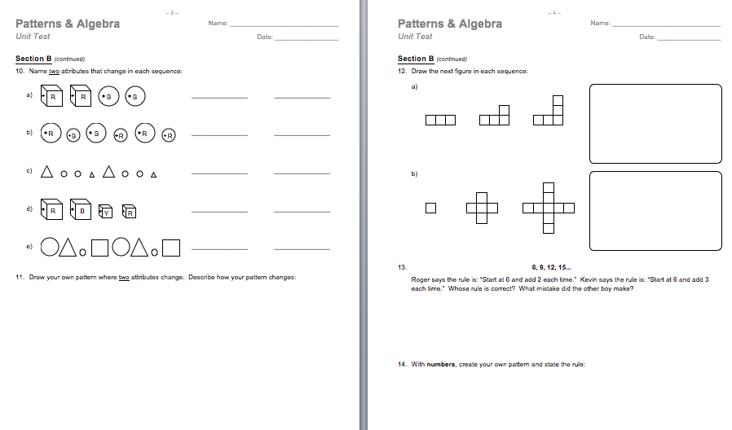

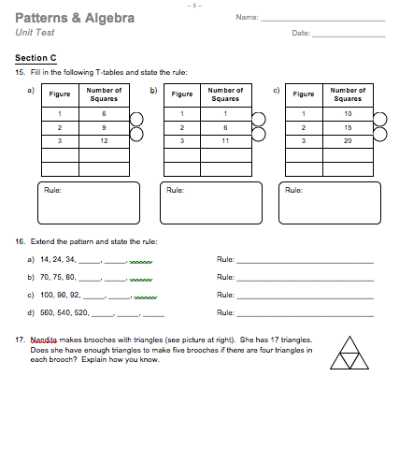

Unit Resources
Alberta Education. (2007). Mathematics Kindergarten to Grade 9 (2007, Updated 2014). In Learn Alberta. Retrieved August 4, 2016, from http://www.learnalberta.ca/ProgramOfStudy.aspx?ProgramId=26061#686409

JUMP Math. (2011- 2016). JUMP Math. In JUMP Math: Multiplying Potential . Retrieved August 4, 2016, from http://jumpmath.org/jump/en/jump_home

Utah State University. (1999-2016), National Library of Virtual Manipulatives , Retrieved August 4, 2016, from http://nlvm.usu.edu/en/nav/vlibrary.html

