Grade 3 - Math
Part 1 - Number Sense
October 11th - December 22th
(11 weeks)

Unit Overview

The math program used by this class is called JUMP Math. The program breaks the Alberta Program of Studies math concepts into the following sections: Patterns and Algebra, Number Sense, Measurement, Statistics and Data Management and Geometry. The JUMP approach strives to integrate a variety of games, magic tricks, activities, extensions and enriched units based on the beauty and wonder of mathematics in the classroom for students to explore and as a means for practicing, applying and extending mathematical skills and concepts. (Jump Math, 2007) This program is helpful to use in a math class for both the students and the teacher, because it steadily builds on concepts. Students are able to become confident with their abilities to complete the math and the teacher is able to assess student understanding at every step and keep everyone involved and on task. During or after each lesson the students will have the opportunity to practice either guided or independent on the skills of the lesson. The student workbooks will be used as an assessment tool throughout the unit, along with challenge question activities, tasks and quizzes. At the end of the unit, the students may complete a unit test.

Rationale for the Unit

This unit on number sense is important to teach, because it provides a foundation for an intuition about numbers. Number sense develops when students connect numbers to their own real-life experiences and when students use benchmarks and referents. This results in students who are computationally fluent and flexible with numbers.
A true sense of number includes and goes beyond the skills of counting, memorizing facts and the situational rote use of algorithms. Mastery of number facts occurs when students understand and recall facts and is expected to be attained by students as they develop their number sense. This mastery allows for application of number facts and facility with more complex computations. Number sense can be developed by providing rich mathematical tasks that allow students to make connections to their own experiences and their previous learning. (Alberta Program of Studies, 2016)

Learner Outcomes of Focus for the Unit
From Mathematics K to Grade 12 Alberta Program of Studies

Number
General Outcomes
- Number: Develop number sense.
Number Sense
Specific Outcomes | Lessons that Address Outcomes
1. Say the number sequence 0 to 1000 forward and backward by:  • 5s, 10s or 100s, using any starting point  • 3s, using starting points that are multiples of 3  • 4s, using starting points that are multiples of 4  • 25s, using starting points that are multiples of 25.  [C, CN, ME] | 12-18, 42-48
2. Represent and describe numbers to 1000, concretely, pictorially and symbolically. [C, CN, V] | 1-7
3. Compare and order numbers to 1000. [C, CN, R, V] | 8-11
4. Estimate quantities less than 1000, using referents.  [ME, PS, R, V] | 13
5. Illustrate, concretely and pictorially, the meaning of place value for numerals to 1000. [C, CN, R, V] | 1, 2, 5-7, 19, 20, 26
6. Describe and apply mental mathematics strategies for adding two 2-digit numerals, such as:  - adding from left to right  - taking one addend to the nearest multiple of ten and then compensating  - using doubles.  [C, CN, ME, PS, R, V] | 28
7. Describe and apply mental mathematics strategies for subtracting two 2-digit numerals, such as:  - taking the subtrahend to the nearest multiple of ten and then compensating  - thinking of addition  - using doubles.  [C, CN, ME, PS, R, V] | 29, 30, 48
9. Demonstrate an understanding of addition and subtraction of numbers with answers to 1000 (limited to 1-, 2- and 3-digit numerals), concretely, pictorially and symbolically, by:  - using personal strategies for adding and subtracting with and without the support of manipulatives  - creating and solving problems in context that involve addition and subtraction of numbers.  [C, CN, ME, PS, R, V] | 20-28
10. Apply mental mathematics strategies and number properties, such as:  - using doubles  - making 10  - using the commutative property  - using the property of zero  - thinking addition for subtraction in order to understand and recall basic addition facts and related subtraction facts to 18.  [C, CN, ME, PS, R, V] | 28
11. Demonstrate an understanding of multiplication to 5 × 5 by:  - representing and explaining multiplication using equal grouping and arrays  - creating and solving problems in context that involve multiplication  - modelling multiplication using concrete and visual representations, and recording the process symbolically  - relating multiplication to repeated addition  - relating multiplication to division.  [C, CN, PS, R] | 34-41

Assessment Tools For Pre-existing Knowledge

Number Words - Prior knowledge required for the unit, involves students understanding their number words and their corresponding numerals. Students will practice writing number words and numbers.

Reading and Writing Words to Ten - Write number words on the board and read the words out loud together. Ask volunteers to write the corresponding numerals under the words. The number sense unit relies on students’ understanding of reading and writing numbers to ten and builds on this knowledge. This pre-assessment will help me understand if there are students that are struggling with this concept.
Counting Forwards and Counting Backwards to 10 - Students will stand in a circle and count forward from 1 to 10. At any point a student in the circle can switch to counting backward and the students have to continue the count. This will be used to assess students’ prior abilities/knowledge of counting forwards and backwards.

Lesson Differentiation and Modifications

Differentiation - The lessons will begin with warm-up discussion questions on the board, these questions will help break the material into steps. Before assigning worksheet questions, the class will discuss and solve questions together. Move through the steps at a pace that fits for the students. Show and model how to solve the problems and then have the students practice with or objects that the students can manipulate.
Extra time can be spent on steps that the students are struggling with. Sample questions will be given for students to work on independently before they move on to the worksheet. Help weaker students with material while the students work on the bonus questions.
The lesson structure combines verbal and written instructions, and information is chunked into steps. Students can use peer assistance while working through questions, along with one-on-one teacher assistance. If students require extra instructions or need to review the steps, they can do this while other students work through questions individually.

Modifications - Instead of working independently on questions, if the most of the class is struggling than more questions can be done on the board, with solve and discuss. Complete additional sequence problems with students that are struggling.
Extension activities for students can be used if there is extra time; these involve more challenging questions or game like activities.

Lesson Sequence Plan Overview
May be Subject to Change
Approx. 50 blocks at 30 minutes each

Lesson # | Lesson Procedure  (Main Learning Activities)  Key Vocabulary  Key Questions  Learning Activities  Technology and Supplies | Assessment/Evaluation  FOR - Pre-assessments for students to learn  AS - assessment as students are learning  OF - assessment of students learning
1 | NS3-1 Place Value - Ones, Tens and Hundreds  Objective:  Students will identify the place value of digits in 2 and 3 digit numbers.  Key Vocabulary:  Number Words - one, ten, hundred - and their corresponding numerals  Key Questions:  How do I place the value of 2 and 3 digit numbers?  Learning Activities:  - Use place value cards and have students identify if the cards are placed correctly on an example 3-digit number.  - Have students practice identifying the place value on each underlined digit of a given number.  - Students will use a column chart of place values and practice correctly writing the digits in each column.  Technology and Supplies:  Place Value Cards, SMART board, Whiteboard, Student workbooks | Have students explain if the number was placed correctly. (FOR)  Use the class discussion to observe the students abilities. (AS)  Provide sample questions for the students to work on independently as an assessment to gauge if the students are ready to do the work on the worksheet. (FOR, OF)
2 | NS3-2 Place Value  Objective:  Students will understand the value of digits in 2 and 3-digit numbers.  Key Vocabulary:  Ones, tens, and hundreds digit, value  Key Questions:  What is the value of each digit in a number?  Learning Activities:  - Students will break numbers apart into each digit and their corresponding value.  - They will identify which digit in each number is worth more.  Technology and Supplies:  SMART board and Whiteboard, Student workbooks | Formative assessment while students work on questions. (AS)  Begin to make mental notes of students’ abilities. (FOR)  Check for understanding and provide extra explanation for students that are struggling. (AS)
3 | NS3-3 Writing and Reading Number Words  Objective:  Students will read and write number words to twenty and multiples of ten up to ninety.  Key Vocabulary:  Numeral, number word, ones and tens digits  Key Questions:  How do I read and write number words?  Learning Activities:  - Students will read number words out loud and write the corresponding numeral beside it.  - Using equations students will fill in the missing number word.  - Students will begin to identify digits that are the same in number words.  Technology and Supplies:  Whiteboard, Student workbooks | Have students write numerals beside number words. (FOR)  Observation for participation and effort, following of instructions, mentally noting the different abilities in the classroom, following expectations, ask questions to check for understanding. (FOR, AS)  Students will write the missing number words in their notebooks. (OF)
4 | NS3-4 Writing Numbers  Objective:  Students will read and write number words up to nine hundred ninety-nine.  Key Vocabulary:  Numeral, number word, digit  Key Questions:  How do I read and write number words?  Learning Activities:  - Have students describe what a number word means and ask if they can come up with an addition sentence for the word.  - Students will write addition sentences for words they find on the number line.  - Have students practice writing numerals for number words and number words for numerals.  Technology and Supplies:  Whiteboard, SMART board, Number lines | Observation for abilities, staying on task, following instructions, and following work expectations. (FOR, AS)  Check understanding using an assessment question that has students writing number words for numerals and numerals for number words. (OF)
5 | NS3-5 Representation with Base Ten Materials  Objective:  Students will practice representing numbers with base ten materials.  Key Vocabulary:  Digit, ones digit, tens digit, ones block, tens block, hundreds block  Key Questions:  How can I use blocks to show number values?  Learning Activities:  - Show students how to use hundreds chart to represent large numbers using hundred, tens and ones blocks.  - Students will practice showing numbers using blocks.  Technology and Supplies:  SMART board and Whiteboard, Number blocks, Hundreds chart | Formative assessment while students work on questions. Begin to make mental notes of students’ abilities. (FOR, AS)  Check for understanding and provide extra explanation for students that are struggling. (AS)  Students will independently solve a sample question and share the answer. (OF)  Students will create numbers using blocks. (OF)
6 and 7 | NS3-6 Representation in Expanded Form  Objective:  NS3-7 Representation Numbers - Review  Students will replace a number with its expanded numeral form and vise versa.  Key Vocabulary:  Digit, numeral  Key Question:  How can I write numbers in expanded form?  Learning Activities:  - Students will draw block numbers on grid paper for several numbers and practice recording the numbers in expanded form using numerals and number words.  - Students will play a game that has them finding their number partner in the room, when each of them has the number represented in a different way.  - Students will review the learning of number sense done so far showing numbers with blocks.  Technology and Supplies:  SMART board, Grid paper, Make up your own cards handout, blocks | Observation for participation and effort, following of instructions, mentally noting the different abilities in the classroom, following expectations. (FOR, AS)  Ask questions to check for understanding during whole group discussion. (AS)  Students will complete an assessment question that has them expanding several numbers using numerals instead of words. (OF)  Students will complete an assessment question that has them expanding several numbers using blocks. (OF)
8 and 9 | NS3-8 Comparing Numbers  NS3-9 Comparing and Ordering Numbers  Objective:  Students will use base ten materials to determine which is larger.  Key Vocabulary:  Hundreds, tens, ones, base ten blocks, greater than, less than  Key Questions:  What does greater than and less than mean?  Learning Activities:  - Introduce students to the phrases “greater than” and “less than.” Have students practice using the phrases when comparing two numbers.  - Students will build numbers using base blocks and identify which number is greater.  - Students will compare two numbers after writing the value of their digits and determine which is greater.  Technology and Supplies:  Whiteboard, Blocks, Student workbooks | Have students compare two numbers and identify which is greater than and less than. (FOR)  Observe students as they practice on the questions and extend the question. (AS)  Ask students to model their answers using blocks. First they must correctly build the numbers with blocks and then they must identify which number is greater (OF)
10 | NS3-10 Differences of 10 and 100  Objective:  Students will recognize when numbers are different by 10 or 100.  Key Vocabulary:  Difference, expanded form, sum  Key Questions:  What is the difference between a set of two numbers?  Learning Activities:  - Students will compare numbers and write whether it is 1 more or less, 10 more or less, or 100 more or less.  - Students will describe what digit they look at to understand how much more or less a number is.  Technology and Supplies:  Whiteboard, hundreds chart pieces handout | Have students name shapes. Have students describe the shapes and what makes them different from each other to check for student understanding. (FOR)  As students are practicing in pairs, walk around and observe/listen as they cross over multiples of a hundred when adding and subtracting 10. (AS)  Students will write each number in expanded form and then explain how much more or less the first number is than the second number. (OF)
12 and 13 | NS3-12 Counting by 2s  NS3-13 Counting by 5s and 25s  Objective:  Students will use patterns to skip count by 2s.  Students will use patterns to skip count by 5s and 25s.  Key Vocabulary:  Skip counting, odd, even  Key Questions:  How can I use a number line to help me count by 2s?  Learning Activities:  - Show students how to skip count using a number line.  - Students will practice skip counting by 2s from 20 to 30 and 60 to 70.  - Students will fill find the missing numbers in each pattern.  Technology and Supplies:  SMART Board, White Board, Play money: quarters and nickels | Have the class read out the skip counting as a group. (FOR, OF)  Students will fill in the missing number for each pattern. (AS, OF)  To check for understanding, have students circle the numbers that were skipped by 2 on their own number line. (OF)
14 | NS3-14 Counting by 2s, 3s and 5s  Objective:  Students will count by 3s. Students will decide whether skip counting by 2, 3, or 5 should be done given endpoints on a number line with a specified number of places.  Key Vocabulary:  Skip counting  Key Questions:  How can I skip count by 3s?  When should I skip count by 2, 3, or 5?  Learning Activities:  - Review skip counting by 2 and by 5.  - Have students practice skip counting by extending a pattern.  - Students will fill in the missing numbers in pattern by skip counting by 2, 3 and 5s.  Technology and Supplies:  SMART Board, White Board | Ask students to describe a pattern in ones digits. (FOR, AS)  Have students write the missing number in a pattern of skip counting. (AS, OF)  Students will identify which number they will skip count by to find a given number in a set of numbers. (OF)
15 and 16 | NS3-15 Counting Backward by 2s and 5s  NS3-16 Counting by 10s  Objective:  Students will count backwards by 2s from any number and by 5s from any multiple of 5.  Key Vocabulary:  Skip counting, counting forwards and counting backwards  Key Questions:  How can I count forwards and backwards by a number?  Learning Activities:  - Students will have to figure out the number the teacher is counting forwards or backwards by and then find the missing number.  - Using number lines students will count back by 10s by skipping every second number they would say by counting back by 5s.  Technology and Supplies:  White board, number line | For a pre-assessment, have students identify the number I am counting forward by, by holding up their fingers. (FOR)  Observe students as they count forward and backward to identify numbers in a pattern. (AS)  For assessment students will identify what the next number in a sequence is. (OF)
17 | NS3-17 Counting by 2s, 3s, 4s, 5s and 10s  Objective:  Students will count by 4s and then will choose between counting by 2s, 3s, 4s, 5s, or 10s.  Key Questions:  Which number should I skip count forward by?  Learning Activities:  - Write a pattern on the board and have students finish the rows.  - Students will predict the next two rows in their notebooks.  - Students will practice skip counting by 4, starting a various numbers.  - Give students a set of numbers and a number between. Students will choose between different skip counts to figure out which works.  Technology and Supplies:  Whiteboard, Notebooks | Observation for participation and effort, following of instructions, mentally noting the different abilities in the classroom, following expectations. (FOR, AS)  Have students practice skip counting by 4, starting a various numbers. (FOR, AS)  Ask questions to check for understanding: What should I skip count by if I want the same number to come right after 30 and right before 26?. (AS)  Have students practice by providing examples of numbers where missing numbers are filled incorrectly, so that students need to find the error. (OF)
18 | NS3-18 Counting by 100s  Objective:  Students will extend patterns that count by 100.  Key Questions:  How can I extend a pattern to 100?  Learning Activities:  - Have students practice and review adding 100 to extend the patterns with ones and tens.  - Students will repeat the sequencing for counting back by 100.  Technology and Supplies:  White board | Formative assessment while students work on questions. Begin to make mental notes of students’ abilities. (FOR, AS)  Have students describe the sequence without just listing the individual items. (AS)  Observe students as they practice and create patterns on their own. (AS)  To assess have students complete a couple sample questions that have them continuing patterns. (OF)
19 and 20 | NS3-19 Regrouping  NS3-20 Regrouping (Advanced)  Objective:  Students will extend patterns that count by 10.  Key Vocabulary:  Tens blocks, ones blocks, trading  Key Questions:  How can I extend patterns by 10?  Learning Activities:  - Students will group blocks into tens for various numbers.  - They will practice translating pictures into number sentences.  - Students will identify how many tens and ones are in a number.  Technology and Supplies:  Whiteboard, SMART board. Blocks or cubes, straws or elastics. | Observation for participation and effort, following of instructions, mentally noting the different abilities in the classroom, following expectations. (FOR, AS)  Have each student say how many blocks are left after the ten ones are traded in for a tens block. (AS, OF)  Observe students work on practice problems, ask students to explain how they found how many tens and ones for one of the questions they are working on. (AS, OF)
21 | NS3-21 Adding 2-Digit Numbers  Objective:  Students will add 2-digit numbers without regrouping.  Key Vocabulary:  Sum  Key Questions:  How can I add 2-digit numbers?  Learning Activities:  - Students will break addition problems into steps and refer to the base ten models.  - Students will draw base ten models to add more 1 and 2 digit numbers where regrouping is not required.  Technology and Supplies:  Student workbooks, Building blocks, Whiteboard. | Formative assessment while students work on questions. Make mental notes of students’ abilities and progress. (FOR, AS)  Have students explain in their own thinking how many blocks they might need later on. (FOR, AS)  Ask students to describe how the numbers in the table change. (AS)  Have students predict the gaps in terms in the t-table on the board and have them help extend the table on their own paper. Before going over it as a class. (AS, OF)  To assess have students complete a couple sample questions (quiz) that have them continuing t-table sequences. (OF)
22 | NS3-22 Adding with Regrouping (or Carrying)  Objective:  Students will add 2-digit numbers with regrouping.  Key Vocabulary:  Regrouping, carrying  Key Questions:  How can I group numbers to add 2-digit numbers?  Learning Activities:  - Students will use charts to show how ones and tens are grouped.  - Beside the charts students will write addition statements to show how the columns of the chart can be used in additions statements to help with adding.  Technology and Supplies:  Student workbooks, Whiteboard, Base ten blocks | Ask students to each draw chart for addition statements. As a review of last class concepts. (FOR)  Draw base ten models on the board and have students contribute to creating an addition statement, have them explain their thinking. (AS, OF)  Observe students as they practice drawing their own charts and create addition sentences. (AS)  Students will shade blocks that were added to each figure to make the next figure in a pattern. To check for understanding ask students to explain how the tens and ones are shown separately in the chart. (AS, OF)
23 | NS3-22 Adding with Money  Objective:  Students will add dimes and pennies.  Key Vocabulary:  Fewer, fewest, cent  Learning Activities:  - Students will compare dimes and pennies to the place values of ones and tens.  - Students will use charts to add up dimes and pennies the same way the added 2 digit numbers.  Technology and Supplies:  Student workbooks, Whiteboard, Dimes and pennies | Formative assessment while students work on questions. (FOR, AS)  Check for understanding and provide extra explanation for students that are struggling. (AS, FOR)  Have students create their own charts independently to ensure that every student can regroup dimes for pennies. (FOR)
24 | NS3-24 Adding 3-Digit Numbers  Objective:  Students will add 3-digit numbers with and without regrouping.  Key Vocabulary:  algorithm  Key Questions:  How can I add 3 digit numbers?  Learning Activities:  - Students will group hundreds, tens and ones together to identify a number.  - Students will practice adding more pairs of 3 digit numbers.  - Students will create a chart to break apart numbers into place values and then use the charts to create addition statements for the numbers.  Technology and Supplies:  Student workbooks, Whiteboard | Ask students to each draw chart for addition statements. As a review of last class concepts. (FOR)  Draw base ten models on the board and have students contribute to creating an addition statement, have them explain their thinking. (AS, OF)  Observe students as they practice drawing their own charts and create addition sentences. (AS)  Students will shade blocks that were added to each figure to make the next figure in a pattern. To check for understanding ask students to explain how the tens and ones are shown separately in the chart. (AS, OF)
25 | NS3-25 Subtracting 2 and 3-Digit Numbers  Objective:  Students will subtract without regrouping.  Key Vocabulary:  Standard algorithm  Key Questions:  How can I subtract without grouping?  Learning Activities:  - Students will use base ten blocks to practice taking away blocks to reach a given number.  - Students will compare their base ten models and create a chart to show the subtraction sentence.  - Students will subtract by writing out the tens and ones and then separate the tens and ones using only numerals.  Technology and Supplies:  Student workbooks, Whiteboard, Base ten blocks | Formative assessment while students work on questions. Make mental notes of students’ abilities and progress. (FOR, AS)  Have students explain in their own thinking how many blocks they might need later on. (FOR, AS)  Ask students to describe how the numbers in the table change. (AS)  Have students predict the gaps in terms in the t-table on the board and have them help extend the table on their own paper. Before going over it as a class. (AS, OF)  To assess have students complete a couple sample questions (quiz) that have them continuing t-table sequences. (OF)
26 and 27 | NS3-26 Subtracting by Regrouping  NS3-27 Subtracting by Regrouping Hundreds  Objective:  Students will subtract with regrouping using base ten materials and using the standard algorithm.  Students will subtract 3-digit numbers by borrowing when necessary.  Key Vocabulary:  Standard algorithm, regrouping, “borrowing”  Key Questions:  How can I subtract by grouping?  Learning Activities:  - Students will use charts to show how ones and tens are grouped.  - Beside the charts students will write subtraction statements to show how the columns of the chart can be used in subtraction statements to help with subtracting.  Technology and Supplies:  Student workbooks, Whiteboard, Base ten blocks. | Ask students to each draw chart for subtraction statements. As a review of last class concepts. (FOR)  Draw base ten models on the board and have students contribute to creating an subtraction statement, have them explain their thinking. (AS, OF)  Observe students as they practice drawing their own charts and create subtraction sentences. (AS)  Students will shade blocks that were added to each figure to make the next figure in a chart. To check for understanding ask students to explain how the tens and ones are shown separately in the chart. (AS, OF)
28 | NS3-28 Mental Math  Objective:  Students will decompose number into sums in an organized way and will use pairs making 10 to add ingle-digit numbers.  Students will add multiples of 10 to 1-digit numbers.  Key Vocabulary:  Pair, making 10  Learning Activities:  - Students will explain what happens to the numbers in an addition sentence using pictures.  - Students will identify strategies to help them fill in number sentences that all add to a given number.  - Students will find pairs that make a given number.  Technology and Supplies:  Student workbooks, Whiteboard | Students will explain what happens to the numbers in an addition sentence using pictures. (FOR)  Have students hold up their hands to show how they can find pairs to make a number. (AS, OF)  To check for understanding have students circle a number that would add to a number you give to make a certain number. (OF)
29 and 30 | NS3-29 Parts and Totals  NS3-30 Parts and Totals (Advanced)  Objective:  Students will use pictures and charts to solve word puzzles.  Key Vocabulary:  Difference, total, altogether, how many more than  Key Questions:  How can I find the total by looking at a picture or chart?  Learning Activities:  - Students will examine a picture/word problem on the board and label the total and the difference on the diagram, using words and numerals.  Technology and Supplies:  Student workbooks, Whiteboard | Observation for participation and effort, following of instructions, mentally noting the different abilities in the classroom, following expectations. (FOR, AS)  Have students practice an example on the board as a class and label the total and difference. (FOR, AS)  Ask questions to check for understanding: How many objects? Are there more of one object than another? How many more of the one object than the other? (AS)  Have students practice by providing examples using other objects in the class. Have students write an addition sentence to express the answer. (OF)
31 | NS3-31 Sums and Differences  Objective:  Students will work through word problems to find the sum and difference.  Key Vocabulary:  Difference, sum  Key Questions:  How can I find the sum or difference?  Learning Activities:  - Students will use a chart to fill in information from word problems that will help them solve problem.  Technology and Supplies:  Student workbooks, Whiteboard, SMART board | To check for prior knowledge, have students answer a word problem using information from their own lives. (FOR)  Ask students to fill in the chart on their own after reading through a word problem. (AS, OF)  Have students place the given numbers for a question in a chart and then solve the problem using addition or subtraction. (OF)
32 and 33 | NS3-32 Larger Numbers  NS3-33 Concepts in Number Sense  Objective:  Students will apply the concepts they have learned so far to numbers with 4 or more digits.  Key Questions:  How can use what I already know to read and write numbers with 4 or more digits?  Learning Activities:  - Students will review place value of ones, tens and hundreds.  - Introduce students to thousands place value.  - Students will practice writing thousand numbers using numerals and practice saying the number words correctly.  - Students will review the concepts of number sense covered so far.  Technology and Supplies:  Student workbooks, Whiteboard, SMART board | Review the place values from the unit’s first two lessons. Have students identify the place value of each digit in various numbers. (FOR)  Read aloud thousands numbers with students and then observe as they write the numerals out, and vice versa. (AS, OF)  Students will complete the worksheet, which will be taken in for assessment. (AS, OF)
34 | NS3-34 Arrays  Objective:  Students will model multiplication using arrays.  Key Vocabulary:  Times, multiplication, product, array, row, column  Key Questions:  How can look at pictures to find a sum of numbers?  Learning Activities:  - Students will use arrays and circle equal amounts. They will place number values beside these amounts.  - Students will learn the multiplication symbol and what it means by comparing it to an array.  - Students will try to create an array in as many different ways as they can for a number.  Technology and Supplies:  Student workbooks, Whiteboard, SMART board | Have students circle rows on an array and identify the numbers to match. (FOR)  Observe as students create arrays with counters for a given number. (AS, OF)
35 and 36 | NS3-35 and 36 Adding Sequences of Numbers and Multiplication and Repeated Addition  Objective:  Students will understand multiplication as determining how many altogether when objects are divided into equal sets.  Key Vocabulary:  Times, multiplication, product, array, row, column  Key Questions:  What does the multiplication sign mean?  How is multiplication like dividing a number into equal parts?  Learning Activities:  - Students will count sums out with their fingers and draw arrays to get used to multiplication concepts.  - Students will practice writing multiplication statements using addition statements.  Technology and Supplies:  Student workbooks, Whiteboard, SMART board | Have students practice counting aloud to find the sums. (FOR)  Use the class discussion to observe the students abilities. (AS)  Provide sample questions for the students to work on independently as an assessment to gauge if the students are ready to do the work on the worksheet. (FOR, OF)
37 | NS3-37 Multiplying by Skip Counting  Objective:  Students will multiply by skip counting.  Key Vocabulary:  Product, sum, skip counting  Key Questions:  What does each part of a multiplication sentence mean?  How can use skip counting to multiply?  Learning Activities:  - Students will explain the parts to a multiplication sentence.  - Students will show examples of several products on number lines.  - Students will skip count on their hands to find multiplication sentences.  Technology and Supplies:  Student workbooks, Whiteboard, SMART board | Formative assessment while students work on questions. (AS)  Begin to make mental notes of students’ abilities. (FOR)  Check for understanding and provide extra explanation for students that are struggling. (AS)
38 | NS3-38 Multiplying by Adding On  Objective:  Students will turn products into smaller products and sums.  Key Vocabulary:  Product, sum, skip counting  Key Questions:  How can break numbers apart into smaller groupings of numbers?  Learning Activities:  - Students will write multiplication sentences for numbers.  - Students will add to multiplication sentences and show how the multiplication sentence changes.  Technology and Supplies:  Student workbooks, Whiteboard, SMART board, counters | Observation for participation and effort, following of instructions, mentally noting the different abilities in the classroom, following expectations. (FOR, AS)  Have students practice writing number sentences. (FOR, AS)  Ask questions to check for understanding: What multiplication sentence do you see? What addition sentence do you see? (AS)  Have students practice by providing examples of numbers where missing numbers are filled incorrectly, so that students need to find the error. (OF)
39 | NS3-39 Doubles  Objective:  Students will use doubles and doubling to multiply mentally.  Key Vocabulary:  Double  Key Questions:  How can use doubles to multiply in my head?  Learning Activities:  - Students will look at patterns and explain how they know the double of another using the pattern.  - Students will find the double of a given number by skip counting.  Technology and Supplies:  Student workbooks, Whiteboard, SMART board | Ask students to explain what a double means. As a review of last class concepts. (FOR)  Draw patterns on the board and ask students to predict the double of a number, have them explain their thinking. (AS, OF)  Observe students as they practice filling in the double blanks. (AS)  To check for understanding ask students how they would split a number to find its double.
40 and 41 | NS3-40 Topics in Multiplication  NS3-41 Concepts in Multiplication  Objective:  Students will explore the phrase “times as many”. Students will consolidate their learning done on multiplication so far.  Key Vocabulary:  Sum, product  Key Questions:  What does “times as many” mean?  Learning Activities:  - Introduce students to the phrase “times as many” and draw diagrams for students to examine. Students will group the larger number by the smaller number to find out how many times as many items one person has than the other.  - Students will review the multiplication concepts they have learned so far with practice problems covering previous lessons.  Technology and Supplies:  Student workbooks, Whiteboard, SMART board | Formative assessment while students work on questions. Make mental notes of students’ abilities. (FOR, AS)  Have students finish the times as many pictures individually. (AS)  To assess have students complete a couple sample questions that have them continuing patterns. (OF)
42 and 43 | NS3-42 and 43 Pennies, Nickels and Dimes and Quarters  Objective:  Students will be able to count any combination of pennies, nickels and dimes up to a dollar.  Students will be able to identify 25 cents in any combination of coins.  Key Vocabulary:  Penny, nickel, dime, quarter, skip counting  Key Questions:  Can I count any combination of pennies, nickels and dimes up to a dollar?  How can I add up coins to make 25 cents?  Learning Activities:  - Students will practice adding up combinations of coins by pretending to buy items and explain what coins they would use to add up to the amount.  - Students will count given coins and write the total amount  Technology and Supplies:  Student workbooks, Whiteboard, SMART board, Coins | Observation for participation and effort, following of instructions, mentally noting the different abilities in the classroom, following expectations. (FOR, AS)  Have students practice sorting coins by denomination. (FOR, AS)  Ask questions to check for understanding: How would I add up these coins? Have the student count out loud to add. (AS)  Have students write the total amount after counting the given coins. (OF)
44 and 45 | NS3-44 Counting by 2 or More Coin Values  NS3-45 Counting by Different Denominations  Objective:  Students will be able to count to any combination of coins up to a dollar.  Students will identify how many coins of any particular denomination would need to be added to an amount to make a certain total.  Key Vocabulary:  Penny, nickel, dime, quarter, skip counting  Key Questions:  How can count to any combination of coins up to a dollar?  How many coins of any particular denomination would need to be added to an amount to make a certain total?  Learning Activities:  - Students will review the finger counting technique.  - Students will sort coins by their denomination and then practice adding up any combination of coins up to a dollar.  Technology and Supplies:  Student workbooks, Whiteboard, SMART board, Play money | Observation for participation and effort, following of instructions, mentally noting the different abilities in the classroom, following expectations. (FOR, AS)  Have students practice sorting coins by denomination. (FOR, AS)  Ask questions to check for understanding: How would I add up these coins? Have the student count out loud to add. (AS)  Have students write the total amount after counting the given coins. (OF)
46 | NS3-Least Number of Coins  Objective:  Students will make specific amounts of money using the least number of coins.  Key Vocabulary:  Penny, nickel, dime, quarter, skip counting  Key Questions:  How can make an amount of money using the least number of coins?  Learning Activities:  - Students will practice making amounts of coins with different combinations.  - Students will use a chart to keep track of how many coins they have used.  - They will identify and correct an example of how many coins the teacher uses and explain the correction.  Technology and Supplies:  Student workbooks, Whiteboard, SMART board, Coins | Have students predict the gaps in terms in the t-table on the board and have them help extend the table on their own paper. Before going over it as a class. (AS, OF)  Provide an coin example on the board and ask students to make corrections have them explain their thinking. (AS, OF)  Have students make given amounts using the least number of coins and ask them to explain their answer. (OF)
47 | NS3-47 Dimes and Pennies  Objective:  Students will represent amounts up to $1 in dimes and pennies.  Key Vocabulary:  Dimes, pennies, tens, ones, ten digit, ones digit  Key Questions:  How can I show amounts up to a dollar using dimes and pennies?  Learning Activities:  - Students will use dimes and pennies and make various amounts using only those two types of coins.  - They will use a t-table to keep track of their answers.  Technology and Supplies:  Student workbooks, Whiteboard, SMART board, Dimes and pennies | Observe students as they create a t-table of their answers. (AS, OF)  To check for understanding, ask students to describe a pattern they notice in their table. (OF)
48 | NS3-Making Change Using Mental Math  Objective:  Students will make change for amounts less than $1 using mental math.  Key Vocabulary:  Skip counting, penny, nickel, dime, quarter, loonie, cent, dollar, change  Key Questions:  How can I make change for amounts less than a dollar?  Learning Activities:  - Demonstrate to students how to “count up” to make change. Review the finger counting technique. Model examples for the class.  - Students will practice the skill with play money.  - Students will practice coming up with change amounts using word problems.  Technology and Supplies:  Student workbooks, Whiteboard, SMART board, play money | Have students explain how much money they should get back using the finger counting technique. (FOR)  Use the class discussion to observe the students abilities. (AS)  Provide sample questions for the students to work on independently as an assessment to gauge if the students are ready to do the work on the worksheet. (FOR, OF)
49 and 50 | NS3-49 Lists  NS3-50 Organized Lists  Objective:  Students will use lists to find numbers, which have two properties.  Students will make various amounts of money using specific coins by creating an organized list.  Key Vocabulary:  Penny, nickel, dime, quarter, loonie, cent, dollar, list  Key Questions:  How can I use a list to make numbers or values?  Learning Activities:  - Students will find numbers that are greater than and less than a given number.  - Have students find numbers that are greater than and less than a number by a certain number.  - Students will find numbers that are multiples of other numbers.  Technology and Supplies:  Student workbooks, Whiteboard, SMART board | Observation for participation and effort, following of instructions, mentally noting the different abilities in the classroom, following expectations. (FOR, AS)  Ask students explain how they found the greater than and less than numbers. (AS, OF)  Observe students work on practice problems, ask students to write odd and even numbers that are less than or greater than a given number. (AS, OF)

Unit Handouts
All can be found online here:
http://jumpmath.org/jump/sites/default/files/BLMs%20for%20Cdn%20Edition%20Book%203-1%20NS.pdf

Technology Strategies
SMART Board
For every JUMP Math lesson plan there is a perfectly aligned interactive whiteboard file, complete with teacher prompts, sample questions, drawings, extensions, activities and bonus questions. Further, the JUMP Math SMART Lesson Materials integrate the many exciting and interactive tools and options inherent to this technology. Using interactive whiteboard-ready lesson materials based directly on the JUMP Math lesson plans will help reduce lesson preparation times, enabling teachers to devote more time and energy to reaching and teaching every child. (JUMP Math, 2007) While concrete manipulatives are still relevant for uses in classrooms, virtual manipulatives add to the learning experience. Virtual manipulatives give students prompts, feedback, and answers to problems while working on problems letting the students use more self-exploration.
The SMART board will be used throughout the unit, to help students visualize the patterns and sequences that we will be working with. The board will be used to bring up already built patterns and sequences for the class to analyze, solve and discuss. As a class we can manipulate the sequences, add to the patterns and draw new patterns. The board will be helpful to use because it will save teacher time spent on drawing/writing patterns and sequences, and also allow the students to easily move and add to problems that we are working on.

Virtual Manipulatives.com
Depending on access to computers and the students’ abilities, The National Library of Virtual Manipulatives technology will be used to help students explore number sense by manipulating numbers. This website contains various math manipulatives that students can click on and move around/rearrange. It would help students that require additional hands-on practice with patterns and students that may need that extra engagement of using the technology to work with the problems. As a class, we would use the website manipulatives such as the hundreds chart, pattern blocks or number line to solve a problem that I provide. Each student would use the technology to come up with the solution. Students could have the opportunity to use technology independently with a guided set of questions, while the larger group is working on a separate activity.

Assessment and Evaluation Tools
Unit Evaluation Criteria and Procedures

Student Workbooks - Student AP Books are used frequently as an assessment tool, for guided practice during the lesson or independent practice at the end of the lesson. In most lessons, however, the AP Books are only used after the teacher has led students through a graduated series of challenges or explorations. These are based on the questions in the AP Book or teachers manual, but might involve work with concrete materials, whole class or group discussions, or pencil and paper work on grid paper or in notebooks. Observation of students as they work through the books will take place. On a regular basis, the books will be flipped through to gauge a students progress. If certain students are observed to be struggling, then as the teacher I will take a look through their books to gain an understanding of what concepts need reinforcement and how to proceed with the learning activities.

Anecdotal Records and Observation Notes - During each lesson students will be observed for participation and effort in the lesson activities. In order to understand the concepts the students need to be actively involved in the discussions and questioning process of the lesson activities. I will observe their ability to follow instructions and meet general classroom expectations, such as listening and respectful participation. These expectations help create a positive classroom environment conductive to learning. During the first few lessons I will focus on mentally noting the different abilities in the classroom throughout the lessons and afterwards make notes on the observations. Student responses to questions and as they work independently on practice questions will be observed. These observation notes will be considered formative assessments of the students learning.

Challenges, questions and tasks - During or after most of the lessons, with an exception of a few, the students will complete a sample assessment question individually. The question will be based on the material covered in the day’s lesson. While students are working on the question, I will walk around and observe and make notes of the questions that the students ask when the need help. This will help me assess the students understanding of the material and help guide the learning that needs to happen next. Tasks and challenges that the students may work on in pairs will be used to evaluate student understanding also. The product that the students produce during the challenges/tasks will be used to assess the students’ abilities to explain their thinking to others and to solve problems collaboratively.

Quiz Question and Unit Test - The quiz question and the unit test will be used to summatively assess what the students have learned throughout the unit. The questions on the unit test summarize the key learning’s from the unit objectives.

Unit Test - Patterns and Algebra Part 1
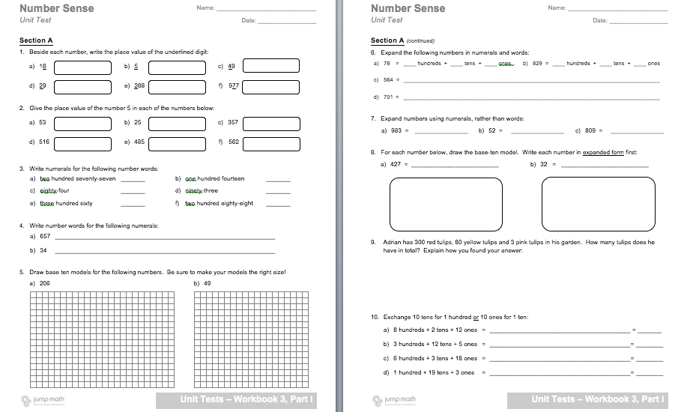

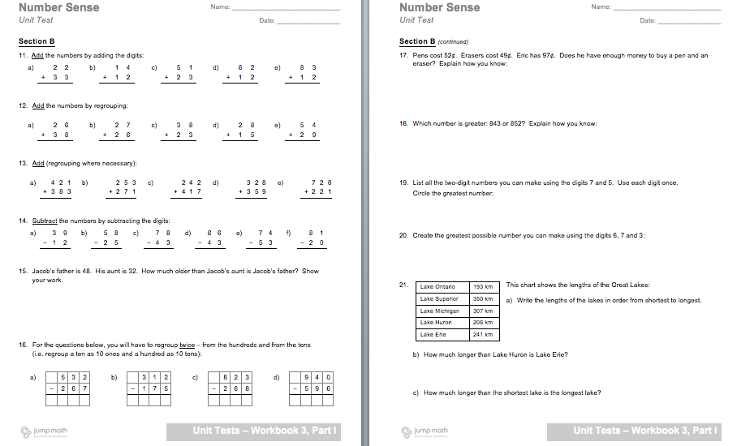

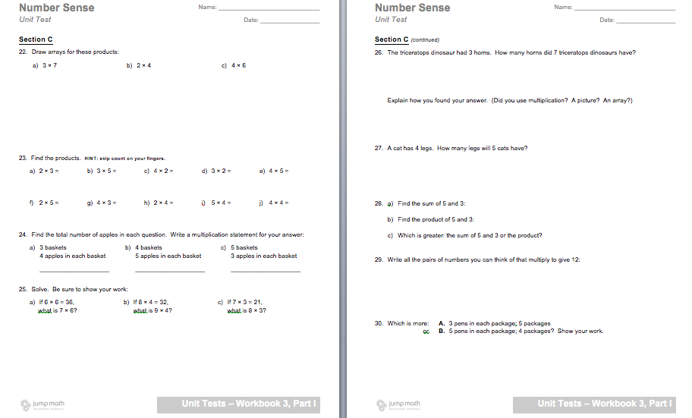

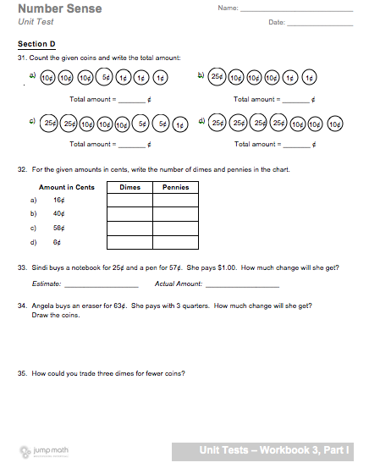

Unit Resources
Alberta Education. (2007). Mathematics Kindergarten to Grade 9 (2007, Updated 2014). In Learn Alberta. Retrieved August 4, 2016, from http://www.learnalberta.ca/ProgramOfStudy.aspx?ProgramId=26061#686409

JUMP Math. (2011- 2016). JUMP Math. In JUMP Math: Multiplying Potential . Retrieved August 4, 2016, from http://jumpmath.org/jump/en/jump_home

Utah State University. (1999-2016), National Library of Virtual Manipulatives , Retrieved August 4, 2016, from http://nlvm.usu.edu/en/nav/vlibrary.html

