Grade 3 Math Year Timeline | 2016-2017 CALENDAR

September 2016
Sun | Mon | Tue | Wed | Thu | Fri | Sat | Notes:
 |  |  |  | 1 | 2 | 3 | Sep 01 - Sep 02: PD Day  Sep 05: Labor Day
Sep 05: Stat Holiday

Sep 06: First Day of School
4 | 5 | 6 | 7 | 8 | 9 | 10 | Sep 06: First Day for students  Sep 30: PD Day
 |  |  |  |  |  |  | Sep 30: PD Day
11 | 12 | 13 | 14 | 15 | 16 | 17 | Part 1 - Introduction and Review
 |  |  |  |  |  |  | (2 weeks)
18 | 19 | 20 | 21 | 22 | 23 | 24 | Part 1 - Patterns and Algebra
 |  |  |  |  |  |  | (3 weeks)
25 | 26 | 27 | 28 | 29 | 30 |  | Week 1 - PA3-1 - PA3-6
 |  |  |  |  |  |  | Week 2 - PA3-7 - PA3-13

October 2016
Sun | Mon | Tue | Wed | Thu | Fri | Sat | Notes:
 |  |  |  |  |  | 1 | Oct 10: Thanksgiving Day - No School
 |  |  |  |  |  |  | Oct 20: Division PD Day
2 | 3 | 4 | 5 | 6 | 7 | 8 | Oct 21: School PD Day  Oct 31: Halloween
 |  |  |  |  |  |  | Week 3 - PA3-14 - PA3-19
9 | 10 | 11 | 12 | 13 | 14 | 15 | Part 1 - Number Sense
 |  |  |  |  |  |  | (4 weeks)
16 | 17 | 18 | 19 | 20 | 21 | 22 | Week 1 - NS3-1 - NS3-14
 |  |  |  |  |  |  | Week 2 - NS3-15 - NS26
23 | 24 | 25 | 26 | 27 | 28 | 29 | Week 3 - NS3-27 - NS3-39
 |  |  |  |  |  |  | Week 4 - NS3-40 - NS3-50
30 | 31

November 2016
Sun | Mon | Tue | Wed | Thu | Fri | Sat | Notes:
 |  | 1 | 2 | 3 | 4 | 5 | Nov 11: Remembrance Day - No School
 |  |  |  |  |  |  | Part 1 - Measurement
6 | 7 | 8 | 9 | 10 | 11 | 12 | (4 weeks)
 |  |  |  |  |  |  | Week 1 - ME3-1 - ME3-4
13 | 14 | 15 | 16 | 17 | 18 | 19 | Week 2 - ME3-5 - ME3-9
 |  |  |  |  |  |  | Week 3 - ME3-10 - ME3-13
20 | 21 | 22 | 23 | 24 | 25 | 26 | Week 4 - ME3-14 - ME3-17
27 | 28 | 29 | 30

December 2016
Sun | Mon | Tue | Wed | Thu | Fri | Sat | Notes:
 |  |  |  | 1 | 2 | 3 | Dec 02: PD Day
 |  |  |  |  |  |  | Dec 23: Last Day Before Winter Holidays
4 | 5 | 6 | 7 | 8 | 9 | 10 | Dec 25: Christmas Day
 |  |  |  |  |  |  | Part 1 - Probability and Data Management
11 | 12 | 13 | 14 | 15 | 16 | 17 | (3 weeks)
 |  |  |  |  |  |  | Week 1 - PDM3-1 - PDM3-4
18 | 19 | 20 | 21 | 22 | 23 | 24 | Week 2 - PDM3-5 - PDM3-10
 |  |  |  |  |  |  | Week 3 - PDM3-11 - PDM3-14
25 | 26 | 27 | 28 | 29 | 30 | 31
 |  |  |  |  |  |  | Dec 24 - Jan 09: Winter Holidays

January 2017
Sun | Mon | Tue | Wed | Thu | Fri | Sat | Notes:
1 | 2 | 3 | 4 | 5 | 6 | 7 | Jan 01: New Year’s Day
 |  |  |  |  |  |  | Jan 09: First Day Back After Winter Break
8 | 9 | 10 | 11 | 12 | 13 | 14 | Jan 30: PD Day
 |  |  |  |  |  |  | Part 1 - Geometry
15 | 16 | 17 | 18 | 19 | 20 | 21 | (4 weeks)
22 | 23 | 24 | 25 | 26 | 27 | 28 | Week 1 - G3-1 - G3-4
 |  |  |  |  |  |  | Week 2 - G3-5 - G3-9
29 | 30 | 31 |  |  |  |  | Week 3 - G3-10 - G3-14
 |  |  |  |  |  |  | Week 4 - G3-15 - G3-17

February 2017
Sun | Mon | Tue | Wed | Thu | Fri | Sat | Notes:
 |  |  | 1 | 2 | 3 | 4 | Feb 14: Valentine’s Day
 |  |  |  |  |  |  | Feb 20: Stat Holiday
5 | 6 | 7 | 8 | 9 | 10 | 11 | Feb 21 & 22: No School DIL teachers
 |  |  |  |  |  |  | Feb 23 & 24: SWATCA
12 | 13 | 14 | 15 | 16 | 17 | 18 | Part 2 - Patterns and Algebra
 |  |  |  |  |  |  | (3 weeks)
19 | 20 | 21 | 22 | 23 | 24 | 25 | Week 1 - PA3-20 - PA3-26
 |  |  |  |  |  |  | Week 2 - PA3-27 - PA3-31
26 | 27 | 28 |  |  |  |  | Week 3 - PA3-32 - PA3-36

March 2017
Sun | Mon | Tue | Wed | Thu | Fri | Sat | Notes:
 |  |  | 1 | 2 | 3 | 4 | Mar 13: Divisional Spiritual Development Day
 |  |  |  |  |  |  | Mar 24: PD Day
5 | 6 | 7 | 8 | 9 | 10 | 11 | Part 2 - Number Sense
 |  |  |  |  |  |  | (4 weeks)
12 | 13 | 14 | 15 | 16 | 17 | 18 | Week 1 - NS3-51 - NS3-62
 |  |  |  |  |  |  | Week 2 - NS3-63 - NS3- 75
19 | 20 | 21 | 22 | 23 | 24 | 25 | Week 3 - NS3-77 - NS3-89
 |  |  |  |  |  |  | Week 4 - NS3-90 - NS3-96
26 | 27 | 28 | 29 | 30 | 31

April 2017
Sun | Mon | Tue | Wed | Thu | Fri | Sat | Notes:
 |  |  |  |  |  | 1 | Apr 14: Good Friday - No School
 |  |  |  |  |  |  | Apr 16: Easter
2 | 3 | 4 | 5 | 6 | 7 | 8 | Apr 17 - Apr 21: Easter Holidays - No School
 |  |  |  |  |  |  | Part 2 - Measurement
9 | 10 | 11 | 12 | 13 | 14 | 15 | (3 weeks)
 |  |  |  |  |  |  | Week 1 - ME3-18 - ME3-23
16 | 17 | 18 | 19 | 20 | 21 | 22 | Week 2 - ME3-24 - ME3-28  B3-4 Body Image  B3-6; B3-7; B3-8
23 | 24 | 25 | 26 | 27 | 28 | 29 | Week 3 - ME3-29 - ME3-32
30

May 2017
Sun | Mon | Tue | Wed | Thu | Fri | Sat | Notes:
 | 1 | 2 | 3 | 4 | 5 | 6 | May 14: Mother’s Day
 |  |  |  |  |  |  | May 22: Stat Holiday
7 | 8 | 9 | 10 | 11 | 12 | 13 | May 23: PD Day
Part 2 - Probability and Data Management
(8 weeks)
14 | 15 | 16 | 17 | 18 | 19 | 20 | (3 weeks)
 |  |  |  |  |  |  | Week 1 - PDM3-15 - PDM3-17
21 | 22 | 23 | 24 | 25 | 26 | 27 | Week 2 - PDM3-18 - PDM3-20
 |  |  |  |  |  |  | Week 3 - PDM3-21 - PDM3-22
28 | 29 | 30 | 31 |  |  |  | Part 2 - Geometry
 |  |  |  |  |  |  | (4 weeks)
 |  |  |  |  |  |  | Week 1 - G3-18 - G3-24
 |  |  |  |  |  |  | Week 2 - G3-25 - G3-30

June 2017
Sun | Mon | Tue | Wed | Thu | Fri | Sat | Notes:
 |  |  |  | 1 | 2 | 3 | Jun 12: PD Day
 |  |  |  |  |  |  | Jun 18: Father’s Day
4 | 5 | 6 | 7 | 8 | 9 | 10 | Jun 29: Last Day of School for students
 |  |  |  |  |  |  | Jun 30: Non-instruct Last Day/PD Day
11 | 12 | 13 | 14 | 15 | 16 | 17 | Week 3 - G3-31 - G3-37
 |  |  |  |  |  |  | Week 4 - G3-38 - G3-44
18 | 19 | 20 | 21 | 22 | 23 | 24 | Part 2 - Conclusion and Review
 |  |  |  |  |  |  | (2 weeks)
25 | 26 | 27 | 28 | 29 | 30

Timeline is approximate and therefore, subject to change.
Unit Outcomes
The math program used by the school is Jump Math. In JUMP lessons, students practice inquiry in manageable steps. They are expected to discover and understand mathematical concepts by answering questions and working through challenges on their own, but they are also provided with a good deal of rigorous guidance and support from the teacher. (Jump Math, 2016)

The specific Mathematics K - Grade 12 Alberta Program of Studies outcomes that will be addressed in each unit are listed in the charts below:
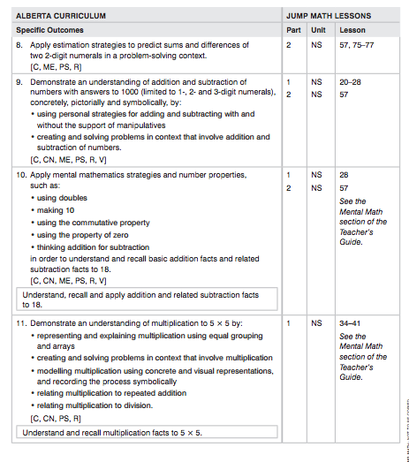
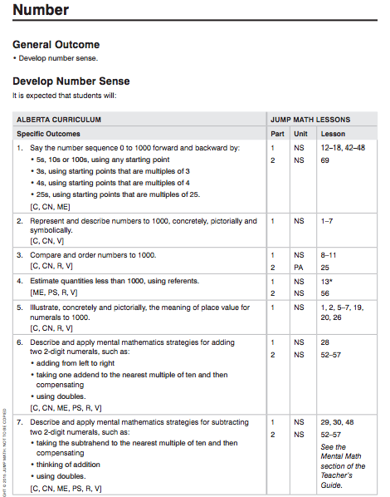

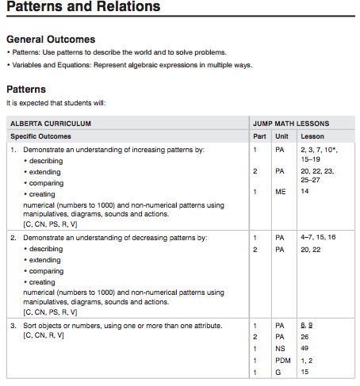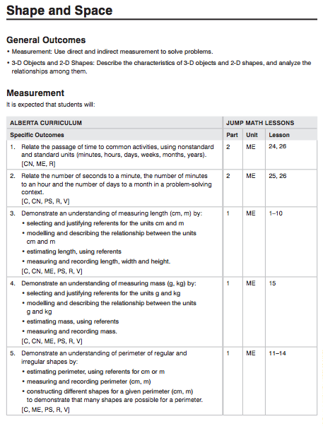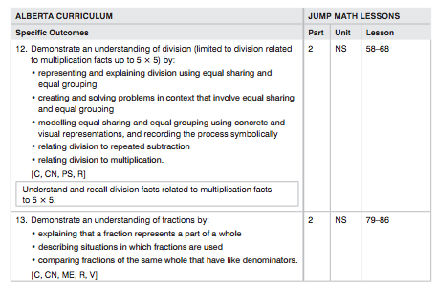
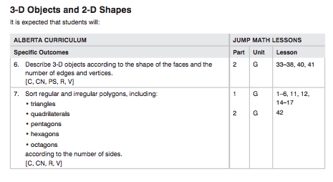

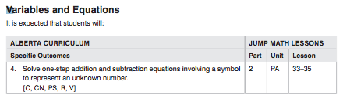

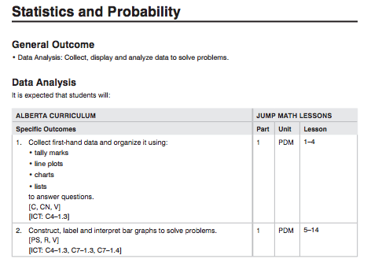

Assessment and Evaluation
The teacher is aware of the students’ levels of understanding, their need for assistance, their attentiveness and their participation. The teacher is able to assess the starting point for the lesson, review prerequisite knowledge, introduce the new concept or skill, increase the level of complexity and difficulty incrementally, assess student understanding at every step and keep everyone involved and on task.
Student AP Books are used frequently as an assessment tool, for guided practice during the lesson or independent practice at the end of the lesson. In most lessons, however, the AP Books are only used after the teacher has led students through a graduated series of challenges or explorations. These are based on the questions in the AP Book or teachers manual, but might involve work with concrete materials, whole class or group discussions, or pencil and paper work on grid paper or in notebooks.
Evaluation Criteria and Procedures
- Participation
- Anecdotal records
- Observations
- AP Books/Notebooks
- Quizzes

