Grade 3 - Social Studies
Unit 1 - What does it mean to be a global citizen?
September 7th - October 10th
(Approx. 20 classes)

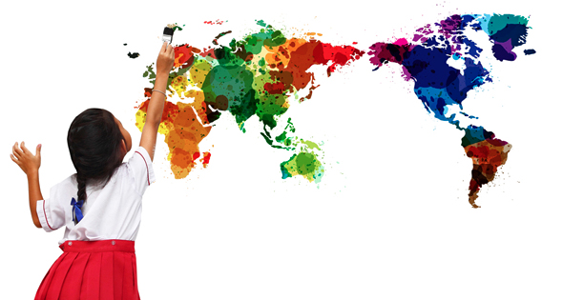

Unit Overview and Rationale
This unit is designed to introduce students to the concept of global citizenship and to help them understand how and in what ways they can become global citizens. Students will be enriching their awareness and appreciation of how people live in other places. Their understanding of global citizenship will be further developed and they will recognize Canada’s involvement in other parts of the world. (Alberta Program of Studies, 2005) The students will begin by exploring how they belong in their own community, they will then expand out into how various communities, including their own contribute to Canada’s identity. This will set the foundation to introduce the concept of global citizenship and initiate the conversation on what it means to be a global citizen. Ultimately, it is important that the students recognize their actions might affect people elsewhere in the world and how the actions of others might affect them.
The core concepts of citizenship and identity are addressed in this unit as the students explore their own identity within their community and connect these aspects to other communities in the world. By first examining how multiple personal, linguistic, social and cultural factors shape their own community and quality of life, it can help the students begin to understand how other communities in other parts of the world are shaped by these same factors, just in different ways. As the students communicate with other children in their class and than children in other parts of the world they are able to describe their own Canadian identity and values of citizenship as they learn about the experiences and perspectives of other Aboriginal, Francophone and/or linguistic, cultural and ethnic groups present in their class and in the world.
Powerful teaching and learning is reflected in the unit tasks as the students are bringing their own perspectives, cultures and experiences to the social studies classroom. They are constructing meaning in the context of their lived experience through active inquiry and engagement with their school and community. (Alberta Program of Studies, 2005) This is shown in the final task as the students prepare questions to ask young people in another community. The students will research and learn about these communities and about the residents' perceptions of Canada by contacting and communicating with people who live there. (Learn Alberta, 2014) This will provide students with the opportunity to emphasize with other viewpoints and perspectives and allow them to recognize the local, national and global connections between themselves and others.

Special Considerations
This unit will serve as the introduction to our Grade 3 Social Studies Connecting to the World focus before we begin to study the individual communities of India, Peru, Ukraine and Tunisia. It will take place in the first couple of weeks in September and will require a minimum of 10 classes consisting of 30 minutes each to complete. The unit is designed on the assumption that the participating students have met the social studies objectives for Grade 1 and 2, those being the study of Citizenship: Belonging and Connecting and the examination of Communities in Canada. It is important that students have this background knowledge prior to this unit, because the unit uses the knowledge as building blocks to introduce the concept of global citizenship.
Throughout the unit students will be sharing their opinions and experiences with others, as well as asking questions to each other about learn about these opinions and experiences. This could present sensitive topics of what others are facing and may be an issue depending on the families or community of the students involved in sharing. To proactively address this issue, there will be an aspect incorporated into the lesson sequence to discuss how to frame questions and responses in a positive manner that respects others. The teacher will explicitly model this and the students will have time to practice with each other before they communicate with children from other communities.
Technology makes international education reachable by far-flung districts that wouldn't otherwise have the ability to access knowledge and information about other cultures and other peoples. (Edutopia, 2007) ICT outcomes are addressed in this unit, as the students will be using technology to research and learn about how people live in other parts of the world. Students will use e-mail to communicate with children in other communities and will have to demonstrate computer proficiency in order to successfully accomplish the task.
Other subject areas can be integrated into the unit, depending on students’ questions on what life is like in other communities there could be opportunities to incorporate aspects of science or mathematics. The six strands of ELA are largely integrated into this unit, because of the nature of the performance task. Students will read various stories throughout the unit as well as listen to others as well as participate in guided and shared reading. Students will view pictures of other communities and form questions based on what they are seeing. Students will speak as they participate in discussions and ask questions. Students will represent their questions in an appropriate way. Lastly, students will write e-mails to other children.
There are potential current event links in this unit, depending on the event and it’s relevance to Canada or the communities of study: India, Peru, Tunisia and Ukraine.

Unit Objectives: GLOs and SLOs
From the Social Studies and Language Arts Alberta Program of Studies

Social Studies Outcomes
General Outcome 3.2: Global Citizenship
Students will demonstrate an understanding and appreciation of Canada’s roles and responsibilities in global citizenship in relationship to communities in India, Tunisia, Ukraine and Peru.
Specific Outcome 3.1.1.1 | - | Students will demonstrate an awareness of and interest in the beliefs, traditions and customs of groups and communities other than their own
Specific Outcome 3.2.1.1 | - | Students will recognize how their actions might affect people elsewhere in the world and how the actions of others might affect them
Specific Outcome 3.2.1.2 | - | Students will respect the equality of all human beings
Specific Outcome 3.2.2.1 |  | Students will explore how are the rights, responsibilities and roles of citizens in communities around the world the same or different than those of Canadian citizens
Specific Outcome 3.2.2.2 |  | Students will explore environmental concerns that Canada and communities around the world share
Specific Outcome 3.2.2.3 |  | Students will explore ways can individuals and groups contribute to positive change in the world
Specific Outcome 3.2.2.4 |  | Students will explore international organizations support communities in need throughout the world (e.g., UNICEF, Red Cross, Development and Peace)
Specific Outcome 3.2.2.5 |  | Students will explore examples of international organizations formed by individuals (e.g., Free the Children, Médecins sans frontières (Doctors Without Borders))
Specific Outcome 3.2.2.6 |  | Students will explore examples of international organizations formed by nations (e.g., UN)
Specific Outcome 3.S.1.1 | - | Students will evaluate ideas and information from different points of view
Specific Outcome 3.S.7.3 | - | Students will develop questions that reflect a personal information need
Specific Outcome 3.S.7.4 | - | Students will follow a plan to complete an inquiry
Specific Outcome 3.S.7.11 | - | Students will formulate new questions as research progresses
Specific Outcome 3.S.8.2 | - | Students will listen to others in order to understand their points of view

Language Arts Outcomes
General Outcome 1
Students will listen, speak, read, write, view and represent to explore thoughts, ideas, feelings and experiences.

1.1 - Discover and Explore
Express ideas and develop understanding
- connect prior knowledge and personal experiences with new ideas and information in oral, print and other media texts
- explain understanding of new concepts in own words
- explore ideas and feelings by asking questions, talking to others and referring to oral, print and other media texts
Experiment with language and forms
- choose appropriate forms of oral, print and other media texts for communicating and sharing ideas with others

1.2 - Clarify and Extend
Consider the ideas of others
- ask for the ideas and observations of others to explore and clarify personal understanding
Combine ideas
- experiment with arranging and recording ideas and information in a variety of ways
Extend understanding
- ask questions to clarify information and ensure understanding

General Outcome 2
Students will listen, speak, read, write, view and represent to comprehend and respond personally and critically to oral, print and other media texts.

2.1 - Use Strategies and Cues
Use prior knowledge
- share ideas developed through interests, experiences and discussion that are related to new ideas and information

2.4 - Create Original Text
Generate ideas
- organize ideas and contribute to individual or group work
Structure texts
- investigate a variety of ways to write a story and work to add detailed ideas to sustain a story

General Outcome 3
Students will listen, speak, write, view and represent to manage ideas and information.

3.1 - Plan and Focus
Focus attention
- use self-questioning to identify information needed to supplement personal knowledge on a topic
- identify facts and opinions, main ideas and details in oral, print and other media texts
Determine information needs
- ask topic-appropriate questions to identify information needs
Plan to gather information
- contribute ideas for developing a class plan to access and gather ideas and information

3.3- Organize, Record and Evaluate
Organize information
- use graphic organizers such as mind maps, charts, and webs to manage information on characters, plot and setting
3.4- Share and Review
Share ideas and information
- organize and share information on character development and read stories

General Outcome 4
Students will listen, speak, write, view and represent to enhance the clarity and artistry of communication.

4.1- Enhance and Improve
Enhance artistry
- use descriptive words and pictures to add to text
4.2- Attend to Conventions
Attend to grammar and usage
- use a variety of correct sentences, adjectives and verbs in writing
Attend to spelling
- identify misspelled words using phonic and visual memory skills

Unit Integration With Other Subject Areas
As seen above, this social studies unit has language arts outcomes integrated throughout. Many of the activities and projects that the students will be working on throughout this unit involve students listening, speaking, reading, writing, viewing, representing experiences and texts.
The unit encourages students to explore personality traits and decisions that a global citizen would possess, because of this Health outcomes are met within the unit.

Assessment Tools for Pre-existing Knowledge
Build a Foundation of Classroom Community - A focus of this introduction to global citizenship unit is for students to have the opportunity to become aware of the beliefs, traditions and customs of communities other than their own. The social studies program for grade one had students exploring themselves and the community they belong to and the goal of the grade two social studies program was for students to examine different Canadian communities. To review this previous learning and to assess the students pre-existing knowledge of Canada’s role in global communities, students will be asked to share with each other information about themselves, their communities and how they see Canada in relation to the world. Each student will receive a maple leaf cutout that will be divided into the three information sections. Students can choose to draw, write or use a combination of both to fill out their leaf. Afterwards there will be time for the students to share their leaf and the information on it with the class. I will observe and make notes on the information shared and connect it to what pre-existing knowledge the students already have on the concepts we will be covering.

Questioning - The unit is designed with a theme of inquiry in mind. Students will be encouraged to develop their own meaning to the question of what it means to be a global citizen. Questioning will be used as an assessment tool throughout the unit to discover students pre-existing knowledge and to encourage students to think and dig deeper to answer their own questions.

Lesson Sequence Plan Overview
May be Subject to Change
Approx. 20 blocks at 30 minutes each

Lesson 1 and 2: The Names and Identity
Learning Outcomes/Key Questions and  Lesson Procedure (Activities) | Assessment/ Differentiation Modifications/ Materials  Technology/ Resources
Learning Outcomes:  Social Studies -  Specific Outcome 3.1.1.1  Specific Outcome 3.S.1.1  Specific Outcome 3.S.8.2  Language Arts -  Specific Outcome 1.1.1  Specific Outcomes 1.1.3  Specific Outcome 1.2.1  Specific Outcome 2.1.1  Specific Outcome 3.4.1  Specific Outcome 4.1.1  Key Vocabulary:  - Characteristics, Community, Cultural Diversity, Traditions  Key Questions:  How does a name contribute to one’s identity?  Learning Activities:  - Play the name ball game to learn names. Students stand in a circle and throw/roll ball to each other, saying each other’s names.  - Hand out a wide Popsicle stick to each student. Have students write their name on a stick.  - Have students bring stick to carpet area and read The Name Jar book together. Ask students why names are important. Brainstorm and discuss on the board. Connect to vocabulary words from previous years social studies such as characteristics, community, cultural diversity and traditions. Show students the class name jar and have them place their Popsicle sticks in jar.  - Students will then make a name stamp to act as a nametag. (Stamps will be used later on)  - To summarize the activity the students will write a sentence on the back of their name stamp, using the prompt “My name is important because…” | Assessment:  Begin to mentally note the different abilities seen in the students. Observe students’ participation and effort in activities/discussions.  Students will write a sentence on the back of their name stamp, using the prompt My name is important because…  Differentiation: Verbal and written instructions, chunking, students assisting each other with instructions, teacher one-on-one assistance, showing the model  Modifications:  The Name Ball game can be played in PE to provide more time for the Name Jar activity.  Integration:  The Name Ball game can be connected to outcomes from PE. The creation of the name stamps ties to the art unit of lines and colour.  Materials:  The Name Jar, by Yangsook Choi, craft supplies for stamps: pipe cleaners, glue, cardboard squares,  Popsicle stick and Name Jar (a jam jar)  Technology:  SMART board  Resources:  Choi, Y. (2001). The Name Jar. New York: Dell Dragonfly Books.
Lesson 3: Belonging in Groups
Learning Outcomes/Key Questions and  Lesson Procedure (Activities) | Assessment/ Differentiation Modifications/ Materials  Technology/ Resources
Learning Outcomes:  Social Studies -  Specific Outcome 3.1.1.1  Specific Outcome 3.S.1.1  Specific Outcome 3.S.8.2  Language Arts -  Specific Outcome 1.2.1  Specific Outcome 2.1.1  Specific Outcome 3.1.3  Specific Outcome 3.1.4  Specific Outcome 3.3.1  Specific Outcome 3.4.1  Key Vocabulary:  - Characteristics, Community, Cooperation, Interests  Key Questions:  How does belonging to groups, such as my class/school community contribute to your identity?  Learning Activities:  - To continue to build classroom community the students will create a personal Bio Glyph based on their qualities and characteristics.  - Afterwards these will be put together to form a class globe and the students will be asked to point out underlying characteristics/qualities that the members of the class share.  - If there is extra time, the book(s) Who Ever You Are and Swimmy will be read after the activity. Invite children to talk about the story. Ask: How did Swimmy feel when he escaped from the tuna and swam alone in the deep sea? What helped Swimmy feel happy again? Why didn't the new school of fish want to swim and play and see things? | Assessment:  Students will select one characteristic/quality (circle one) that they believe contributes to the most to their classroom community and explain why.  Differentiation: Verbal and written instructions, chunking, students assisting each other with instructions, teacher one-on-one assistance, showing the model  Instead of using the bio glyph instructions have students draw themselves and write about their interests.  Modifications:  Extension of time, if needed  Materials:  Whoever You Are, by Mem Fox, Swimmy, by Leo Lionni, Bio Glyph Outlines, Construction paper  Technology:  SMART board  Resources:  http://www.scholastic.com/teachers/book/swimmy#cart/cleanup

Lesson 4: Together We Are Going Places
Learning Outcomes/Key Questions and  Lesson Procedure (Activities) | Assessment/ Differentiation Modifications/ Materials  Technology/ Resources
Learning Outcomes:  Social Studies -  Specific Outcome 3.1.1.1  Specific Outcome 3.S.1.1  Specific Outcome 3.S.8.2  Language Arts -  Specific Outcome 1.1.1  Specific Outcome 1.1.3  Specific Outcome 2.1.1  Specific Outcome 2.4.1  Specific Outcome 3.1.4  Specific Outcome 3.3.1  Specific Outcome 3.4.1  Key Vocabulary:  - Characteristics, Community, Cooperation, Interests  Key Questions:  What classroom rules and expectations do you think are important for our class community?  Learning Activities:  - Together as a class discuss the expectations and rules. Tell students that rules are important because they help create a classroom ready for learning. Have students brainstorm and write down top rules that they believe should be part of our class list. Explain that the top rules picked by everyone will form our class list.  - Students will also fill out a learner profile.  - Provide students with passport journals. Have students fill in their information and take their pictures.  - Explain that we will be using these journals as we explore what it means to be a global citizen and learn about different places in the world.  - Like real passports, they will receive stamps for the places/things we explore as a class. The first stamp students will receive is their name stamp. | Assessment:  Observe the different abilities seen in the students. Observe students’ participation and effort in activities/discussions.  Differentiation: Verbal and written instructions, chunking, students assisting each other with instructions, teacher one-on-one assistance, showing the model  Students could work in small groups to create rule suggestions  Modifications:  Extension of time, if needed  Instead of taking student pictures, students can draw their faces in the picture box.  A group discussion could take place to come up with the rule suggestions, rather than the students writing them down.  Materials:  Student inventory handout, Passport journal booklets, Student name stamps  Technology:  SMART board, Camera  Resources:  http://craftyguides.blogspot.ca/2011/05/little-pretend-passports.html  http://www.activityvillage.co.uk/passport-for-kids

Lesson 5 and 6: Your Canadian Classroom Community
Learning Outcomes/Key Questions and  Lesson Procedure (Activities) | Assessment/ Differentiation Modifications/ Materials  Technology/ Resources
Learning Outcomes:  Social Studies -  Specific Outcome 3.1.1.1  Specific Outcome 3.2.1.1  Specific Outcome 3.S.1.1  Specific Outcome 3.S.8.2  Language Arts -  Specific Outcome 1.1.1  Specific Outcomes 1.1.3  Specific Outcome 1.1.4  Specific Outcome 1.2.1  Specific Outcome 2.1.1  Specific Outcome 3.3.1  Specific Outcome 3.4.1  Key Vocabulary:  - Community, Cultural Diversity, Traditions, Physical Geography, Global, Global Citizenship, Role  Key Questions:  What do I already know about my community, Canadian communities and Canada’s role in the global community?  Learning Activities:  To review this previous learning and to assess the students pre-existing knowledge of Canada’s role in global communities, students will be asked to share with each other information about themselves, their communities and how they see Canada in relation to the world.  - Introduce the concept of citizenship by reading Have You Filled a Bucket Today? by Carol McCloud or Light Your Candle, by Carl Sommer or We Live Here Too! by Nancy Loewen.  - Discuss what it means to be a citizen. Define “citizen” as a member of a community who has rights and responsibilities.  - Explain that it is possible to be a member of different communities at the same time; therefore, there are different levels of citizenship. For example, one is a member of local communities (school, town, city, state), a national community (country), and an international community (the world) all at once.  - Draw a “Circle Map of Citizenship” on a sheet of chart paper as pictured here. Ask students to identify their roles, or how they participate, as citizens at each of the levels depicted. Record their responses.  - Show students a map of Canada. Ask students to identify where we are on the map and explain their reasoning. Ask students to explain some of the physical geography around where we live. Ask students to share any experiences or knowledge they have of other communities in Canada.  - Show students a map of the world and have them identify Canada. Ask students what role Canada plays in the world community. Together come up with a list of words to describe Canada.  - Each student will receive a maple leaf cutout that will be divided into the three information sections: information about themselves, their communities and how they see Canada in relation to the world.  - Students can choose to draw, write or use a combination of both to fill out their leaf.  - Afterwards there will be time for the students to share their leaf and the information on it with the class. | Assessment:  Observe the different abilities seen in the students. Observe students’ participation and effort in activities/discussions. Monitor student responses to questions.  Differentiation: Verbal and written instructions, chunking, students assisting each other with instructions, teacher one-on-one assistance, showing the model, choice to draw or write on leaf  Modifications:  Students could complete their leaf, before the class map discussion.  Materials:  Have You Filled a Bucket Today? by Carol McCloud, Light Your Candle, by Carl Sommer, We Live Here Too! by Nancy Loewen,  Map of Canada,  World Map,  Maple Leaf cutouts, pencil crayons, scissors  Technology:  SMART board  Resources:  http://www.nationalgeographic.com/kids-world-atlas/maps.html  https://teachunicef.org/sites/default/files/documents/units-lesson-plans/global_citizenship_gr_3-5_final_7-13.pdf

Lesson 7 and 8: Roles and Responsibilities
Learning Outcomes/Key Questions and  Lesson Procedure (Activities) | Assessment/ Differentiation Modifications/ Materials  Technology/ Resources
Learning Outcomes:  Social Studies -  Specific Outcome 3.1.1.1  Specific Outcome 3.S.1.1  Specific Outcome 3.S.8.2  Language Arts -  Specific Outcome 1.1.1  Specific Outcomes 1.1.3  Specific Outcome 1.2.1  Specific Outcome 2.1.1  Specific Outcome 3.4.1  Specific Outcome 4.1.1  Key Vocabulary:  - Role, Responsibility, Decision Making, Community, Citizen  Key Questions:  How can I be a good member of the community?  What are examples of roles? What are examples of responsibilities?  What are the roles and responsibilities as a member of the community?  Learning Activities:  Students will be able to explain what values are important to them and what values they think are important to be a good member of the classroom community.  Students will analyze what their roles and responsibilities are as a member in their community.  - The students will participate in a fishbowl exercise, where students move around within two circles and address how they would solve different problems that might occur at school, home or in the community.  - Afterwards they will group their problems as a class based on how difficult/easy they were to solve.  - Write the words “RIGHTS” and “RESPONSIBILITIES” on the board. Give the definition of each word as it relates to the school setting. RIGHTS – a freedom that is protected; what everyone deserves no matter who they are or where they live so we can live in a world that is fair and just RESPONSIBILITIES – duty or something someone should do Discuss the rights and responsibilities objective for learning in a school setting. Brainstorm with students by giving them an example of being responsible.  - In their passport journals, students will describe the difference between a role and a responsibility. Using a combination of drawing and writing they will identify one role they have as a member of the class and a responsibility of that role. | Assessment:  Begin to mentally note the different abilities seen in the students. Observe students’ participation and effort in activities/discussions.  Students will place his or her problem card under a solution category. Students will create their definitions of role and responsibility in their passport journals.  Differentiation: Verbal and written instructions, chunking, students assisting each other with instructions, teacher one-on-one assistance, showing the model, combination of drawing or writing for the journaling  Modifications:  The problems can be grouped, as the students are journaling.  Integration:  The problem solving role scenarios can by integrated with Health outcomes of Relationship Choices - Group Roles and Processes and Interaction.  Materials:  Passport journals, problem cards  Technology:  SMART board  Resources:  http://www.fcps.edu/dss/ips/ssaw/SRR/2013-14/grade1-2.pdf

Lesson 9 and 10: Rights and Responsibilities as Canadian Citizens
Learning Outcomes/Key Questions and  Lesson Procedure (Activities) | Assessment/ Differentiation Modifications/ Materials  Technology/ Resources
Learning Outcomes:  Social Studies -  Specific Outcome 3.1.1.1  Specific Outcome 3.S.1.1  Specific Outcome 3.S.1.3  Specific Outcome 3.S.7.3  Language Arts -  Specific Outcome 1.1.1  Specific Outcomes 1.1.2  Specific Outcome 2.2.1  Specific Outcome 3.3.1  Specific Outcome 3.3.3  Key Vocabulary:  - Role, Responsibility, Quality of Life, Citizen  Key Questions:  What are our rights as citizens of Canada?  What are responsibilities as citizens of Canada?  Learning Activities:  Students will identify what are our rights as citizens of Canada.  Students will identify what are our responsibilities as citizens of Canada.  - Reviews from last class, we all have rights and responsibilities. Introduce students to the Charter of Rights and Freedoms. Explain that it makes sure that everyone in Canada is treated fairly.  - Act out a right for the class. Write the prompt on the board: “The right to…”  - Students will be split up into small groups and will be given a right from the Charter of Rights and Freedoms.  - They will have to interpret the right and create a short role-play to describe it for the class.  - After each role-play students will discuss the right and why it is important. Together we will come up with a definition for a responsibility.  - Students will interpret their own meaning of Canadian rights and responsibilities in their passport journal. | Assessment:  Observe the different abilities seen in the students. Observe students’ participation and effort in activities/discussions. Monitor student responses to questions. Collect student passports and make notes on students’ work.  Differentiation: Verbal and written instructions, chunking, students assisting each other with instructions, teacher one-on-one assistance, modeling how to role play  Modifications:  Instead of students role-playing, they could draw their right on the whiteboard like Pictionary.  Materials:  Passport journals, We Are All Born Free, by Amnesty International, Role Play Scenarios  Technology:  SMART board  Resources:  http://encyclopedia.kids.net.au/page/ca/Canadian_Charter_of_Rights_and_Freedoms

Lesson 11 and 12: Wants vs. Needs and Rights
Learning Outcomes/Key Questions and  Lesson Procedure (Activities) | Assessment/ Differentiation Modifications/ Materials  Technology/ Resources
Learning Outcomes:  Social Studies -  Specific Outcome 3.2.1.1  Specific Outcome 3.2.2.1  Specific Outcome 3.S.1.1  Specific Outcome 3.S.7.3  Specific Outcome 3.S.8.2  Language Arts -  Specific Outcome 1.1.1  Specific Outcome 1.1.2  Specific Outcome 1.1.3  Specific Outcome 1.2.1  Specific Outcome 1.2.3  Specific Outcome 2.1.1  Specific Outcome 3.1.1  Key Vocabulary:  -Rights, Wants, Needs, Quality of Life  Key Questions:  What are the rights of children around the world?  Learning Activities:  Students will discuss the rights of children everywhere.  - Students will play the difference between wants and needs game. (Rights Wants and Needs Activities Document)  - The game has students pretending that they are being sent to a new planet and they are allowed to take a certain number of things. They have to justify and explain their choices.  - After this begin by explaining to students that “rights” are things every child should be able to have or to do, in order to survive and grow to reach their full potential  - Class brainstorm of rights they think children should have.  - After examine the I Have the Right to be a Child text. | Assessment:  Observe students’ participation and effort in activities/discussions. Monitor student responses from class brainstorm. Students will have to compare their choices with another group. As a class we will create a list of rights that children should have. Students will record this list in their passport journals.  Differentiation: Verbal and written instructions, chunking, students assisting each other with instructions, teacher one-on-one assistance, showing the model, students may explain their answers verbally or by writing  Modifications:  The Wants vs. Needs activity can be done as a group or individually.  Materials:  I have the Right to be a Child text, Needs vs. Wants cards  Technology:  SMART board  Resources:  http://www.e-activist.com/ea-campaign/action.retrievefile.do?ea_fileid=14113

Lesson 13 and 14: Rights for Every Child
Learning Outcomes/Key Questions and  Lesson Procedure (Activities) | Assessment/ Differentiation Modifications/ Materials  Technology/ Resources
Learning Outcomes:  Social Studies -  Specific Outcome 3.2.1.1  Specific Outcome 3.2.1.2  Specific Outcome 3.2.2.2  Specific Outcome 3.2.2.3  Specific Outcome 3.S.1.3  Specific Outcome 3.S.4.2  Specific Outcome 3.S.4.4  Specific Outcome 3.S.7.1  Specific Outcome 3.S.8.5  Language Arts -  Specific Outcome 1.1.1  Specific Outcome 1.1.2  Specific Outcome 1.1.3  Specific Outcome 2.1.1  Specific Outcome 3.3.1  Specific Outcome 4.1.1  Key Vocabulary:  Rights, Responsibilities, Quality of Life, Organization  Key Questions:  What are our rights as citizens of the world?  What are our responsibilities as citizens of the world?  Learning Activities:  Students develop an awareness of how the rights of young people protect their ability to enjoy a quality of life.  - The class will look at pictures of children in other parts of the world. The students will analyze the pictures and pick one that stands out for them. They will complete a “I Think, I See, I Wonder” based on the picture.  - Ask students if they believe that all children around the world are equally happy or satisfied with their quality of life. Discuss the reasons why some children may not enjoy a satisfying quality of life (e.g., access to education, poverty, community support, safety, conflict, natural disasters, family situation).  - Introduce the United Nations' Rights of the Children. Explain that it contains 54 articles protecting children's rights and the class is going to read a book describing 14 of these rights. Arrange for students to work with a partner to record the rights they predict might be in the book.  - Read "For Every Child" by UNICEF. Invite students to identify the rights they heard about. Record these rights in a list on the board. Select one of these rights and discuss how not having this right would impact a child's quality of life. Record the consequences if a child did not have the identified right.  - Model this cause and effect relationship with three or four other rights. Invite students to work with a partner to imagine the consequences for several more of the rights. Share each pair's findings with the class, adding to the chart as students offer their ideas.  - Ask students to select a right that they think is especially important and to create a poster in their journal.  - Encourage students to illustrate and explain how not having the particular right affects a child's quality of life. Encourage students to show the most important consequences of this right in a manner that other students will understand. | Assessment:  Observe students’ participation and effort in activities/discussions. Students will complete a “I Think, I See, I Wonder” page. Collect students’ passport journals for evidence of a right and explanation to how not having the right would affect a child’s quality of life.  Differentiation: Verbal and written instructions, chunking, students assisting each other with instructions, teacher one-on-one assistance, showing the model, individual or group work  Modifications:  The poster project could be done on a KidPix program or PowerPoint presentation if computers are available.  Materials:  "For Every Child" by UNICEF, Pictures of people and places  Technology:  SMART board,  Computers/ laptops (optional)  Resources:  http://www.learnalberta.ca/content/ssoc3/html/whathappensif_cc.html  http://www.unicef.org/crc  http://www.unicef.org/rightsite/files/uncrcchilldfriendlylanguage.pdf

Lesson 15 and 16: Global Citizenship
Learning Outcomes/Key Questions and  Lesson Procedure (Activities) | Assessment/ Differentiation Modifications/ Materials  Technology/ Resources
Learning Outcomes:  Social Studies -  Specific Outcome 3.2.1.1  Specific Outcome 3.2.1.2  Specific Outcome 3.2.2.1  Specific Outcome 3.2.2.3  Specific Outcome 3.2.2.5  Specific Outcome 3.S.7.3  Language Arts -  Specific Outcome 1.1.1  Specific Outcome 1.1.2  Specific Outcome 1.2.1  Specific Outcome 1.2.3  Specific Outcome 2.1.1  Specific Outcome 2.4.1  Key Vocabulary:  Citizen, Characteristics, Global Citizenship  Key Questions:  What is a global citizen?  What qualities does a global citizen possess?  Learning Activities:  - Have students share their right posters with the class. In their passport journals students will make a list of the three rights they think are important and share with a partner explaining their choices. Review that a “citizen” as a member of a community who has rights and responsibilities.  - Ask what the difference is between being a citizen (of Canada, for example) and a global citizen. Explain that citizenship is often granted by a government, whereas global citizenship is not. Instead, one can become a global citizen simply by demonstrating certain characteristics, or habits of mind, body, and spirit—anyone can become a global citizen  - Explain that examples of global citizens will be presented in order to further explore what it means to be a global citizen and how global citizens can make a positive difference in the world.  - Share a couple stories and images of individuals that started projects to help others. Ex. Craig Kielburger and Free the Children. Ask students what the individuals depicted have in common.  - Write, “What Is a Global Citizen?” on a white board or have groups of students with poster boards. Ask students to identify the knowledge (head), values (heart), and skills (hand) that these global citizens needed in order to take informed action. Fill in these areas with student responses.  - Have students create a global citizen stamp for journal and read What Does It Mean To Be Global? by Rana DiOrio. (Optional) | Assessment:  Observe students’ participation and effort in activities/discussions. Ask students to explain the difference between being a national and a global citizen. Monitor student responses. Students will identify the knowledge (head), values (heart), and skills (hand) that these global citizens needed in order to take informed action.  Differentiation: Verbal and written instructions, chunking, students assisting each other with instructions, teacher one-on-one assistance, showing the model of the global citizen qualities  Materials:  What Does It Mean To Be Global? by Rana DiOrio,  Passport journals  Technology:  SMART board  Resources:  https://teachunicef.org/sites/default/files/documents/units-lesson-plans/global_citizenship_gr_3-5_final_7-13.pdf

Lesson 17 and 18: Organizations that Help
Learning Outcomes/Key Questions and  Lesson Procedure (Activities) | Assessment/ Differentiation Modifications/ Materials  Technology/ Resources
Learning Outcomes:  Social Studies -  Specific Outcome 3.1.1.1  Specific Outcome 3.2.1.2  Specific Outcome 3.2.2.4  Specific Outcome 3.2.2.5  Specific Outcome 3.2.2.6  Specific Outcome 3.S.1.1  Specific Outcome 3.S.4.2  Specific Outcome 3.S.7.6  Specific Outcome 3.S.7.7  Specific Outcome 3.S.7.8  Specific Outcome 3.S.7.9  Specific Outcome 3.S.8.2  Language Arts -  Specific Outcome 1.1.2  Specific Outcome 2.1.1  Specific Outcome 2.4.1  Specific Outcome 3.1.2  Specific Outcome 3.1.4  Key Vocabulary:  Organization, International Aid  Key Questions:  How do international organizations support communities in need throughout the world?  What are examples of international organizations formed by individuals?  What are examples of international organizations formed by nations?  Learning Activities:  Students learn about the role of international agencies in supporting communities by deciding which organization they would most want to support.  - Suggest to students that every country has problems, including Canada. Invite students to think of the problems they have learned about in this inquiry that face Canada and the four profiled counties (e.g., basic rights, environment).  - Compile a list of these problems. Explain to students that there are hundreds of organizations around the world dedicated to helping communities solve their own problems.  - Introduce students to several local and international aid groups (e.g., Free the Children, Stephen Lewis Fund for Africa, Doctors without Borders, UNICEF, Development Canada, a local food bank).  - Divide students into pairs or small groups. Provide students with a brief factual profile about each organization–the kinds of projects it undertakes, where it operates and any other relevant facts about its approach to international aid. Assign groups of students to present information about one of the organizations to the rest of the class. Invite students to discuss the importance of the work carried out by these agencies.  - As a class, brainstorm the criteria that students might consider in deciding which organization they would most want to support (e.g., meets needs that the student considers to be most important, involves local community people, will produce a long-term positive result). Invite students to consider each of the profiled organizations before making a choice of the one they would be most likely to support.  - In their passport journals, have students write a question that they would ask the organization of their choice about the work they do. | Assessment:  Observe students’ participation and effort in activities/discussions. Observe students as they present information about one of the organizations to the rest of the class. Use the Assessing the Organization Checklist to evaluate the students’ description of their organization.  In their passport journals students will write a question that they would ask the organization of their choice about the work they do.  Differentiation: Verbal and written instructions, chunking, students assisting each other with instructions, teacher one-on-one assistance, showing the model to students  Modifications:  Instead of presenting their organization to the class, students could write their explanation for assessment  Materials:  International Organization Websites, Passport Journals  Technology:  SMART board  Resources:  http://www.freethechildren.org  http://www.doctorswithoutborders.org  http://www.changeforchildren.org  http://kidsforsavingearth.org/index.html  http://www.unicef.org

Lesson 19 and 20: What Does it Mean to be a Global Citizen?
Learning Outcomes/Key Questions and  Lesson Procedure (Activities) | Assessment/ Differentiation Modifications/ Materials  Technology/ Resources
Learning Outcomes:  Social Studies -  Specific Outcome 3.1.1.1  Specific Outcome 3.2.1.2  Specific Outcome 3.S.8.3  Specific Outcome 3.S.8.4  Language Arts -  Specific Outcome 1.1.1  Specific Outcome 1.1.2  Specific Outcome 1.2.1  Specific Outcome 3.2.1  Specific Outcome 3.4.1  Key Vocabulary:  Global Citizenship, Characteristics, Interests  Key Questions:  What traits does a global citizen have?  How can the actions of an individual create positive change?  Learning Activities:  - Read a children’s book about individuals who have taken action as global citizens. After reviewing the characteristics of a global citizen, ask students if it is necessary to portray all of these traits to be a global citizen.  - As a class, identify the knowledge, skills, and values the individuals in the story exhibited, relating them to characteristics of global citizenship previously discussed. Expand by asking how the actions of the individuals caused a movement of positive change beyond their communities. Discuss how local action can lead to global change.  - Explain that as individuals, each of us has a unique personality and specific talents that we can use to make a positive difference in our communities. Have students reflect on their unique talents by viewing together “Which Change maker Personality Are You?” (http://www. storyofstuff.org/movies-all/story-of-change/changemakers).  - Show the cartoons associated with each “personality” and ask students to describe how they think that person would make positive change in the world. Provide child-friendly explanations of each type as needed.  - Ask students to name examples of individuals they know or have learned about who depict some of the above personalities. Then have them determine which personality best reflects their strengths. Once they have selected, have students create a personal emblem that represents their change maker personality and write about how they will use their trait for positive change.  - Share as a whole group and display students’ work in the classroom. | Assessment:  Observe students’ participation and effort in activities/discussions. Monitor student responses to questions. Ask students to name examples of individuals they know or have learned about who depict some of the above personalities.  Students will create a personal emblem that represents their change maker personality and write about how they will use their trait for positive change.  Collect Passport Journals and use rubric to assess student knowledge towards outcomes.  Differentiation: Verbal and written instructions, chunking, students assisting each other with instructions, teacher one-on-one assistance, showing the model  Modifications:  If there is extra time, have students complete the Show What You Know - Solving a Problem chart on pg. 169 Connecting With the World  Integration:  The problem solving role scenarios can by integrated with Health outcomes of Relationship Choices - Group Roles and Processes and Interaction.  Materials:  Aani & the Tree Huggers, by Jeannine Atkins  Bella’s Chocolate Surprise, by Adam Guillain and Elke Steiner  The Carpet Boy’s Gift, by Pegi Deitz Shea  The Librarian of Basra: A True Story from Iraq, by Jeannette Winter  Ryan and Jimmy and the Well in Africa That Brought Them Together, by Herb Shoveller  Technology:  SMART board  Resources:  http://www. storyofstuff.org/movies-all/story-of-change/changemakers  https://teachunicef.org/sites/default/files/documents/units-lesson-plans/global_citizenship_gr_3-5_final_7-13.pdf

Unit Handouts
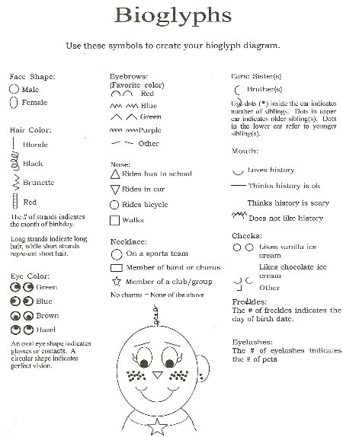

Maple Leaf Outline
Bio Glyph Outline

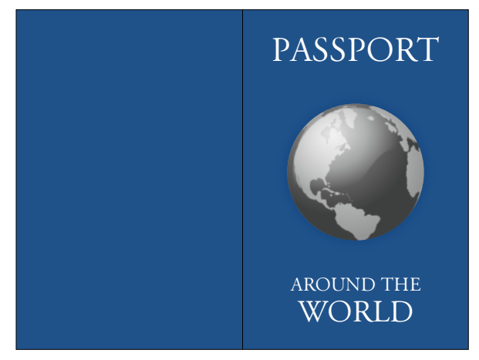
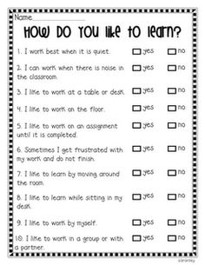

Passport Journal Cover
Student Inventory

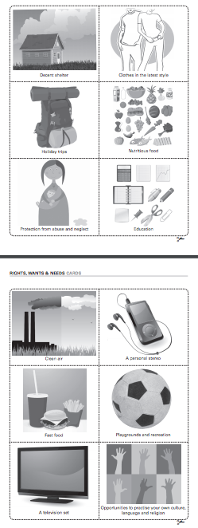
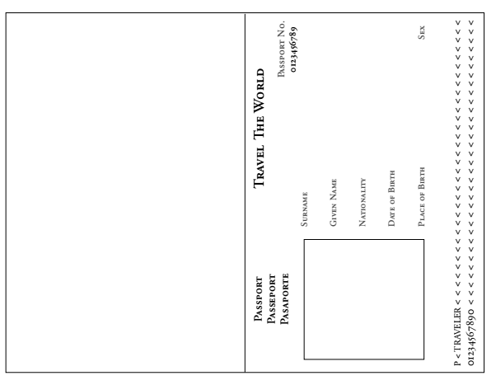

Passport Journal First Page
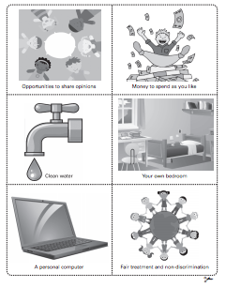

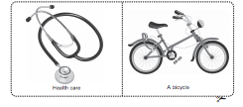
Wants and Needs Cards

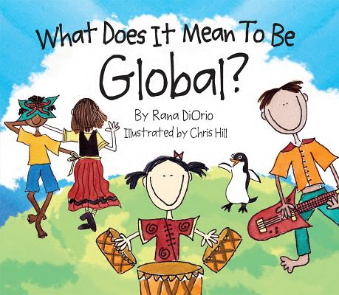
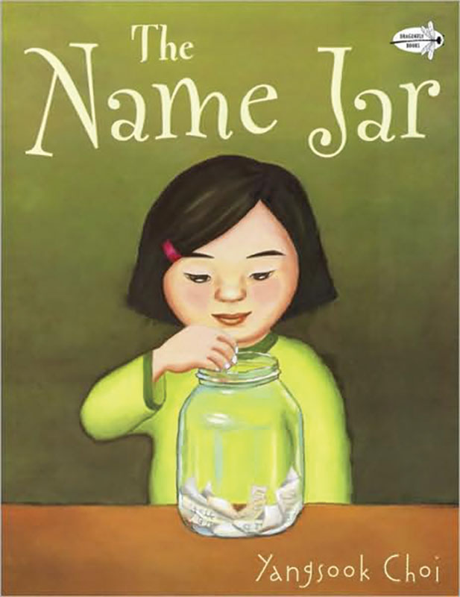
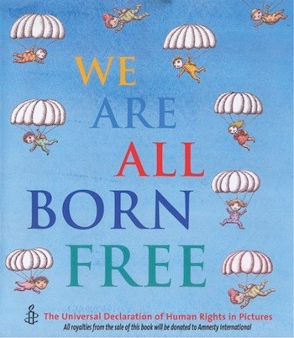
Literature Links
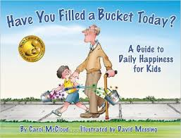

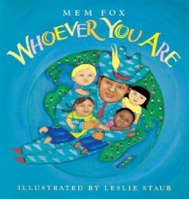
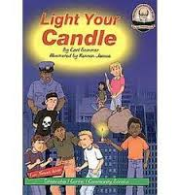
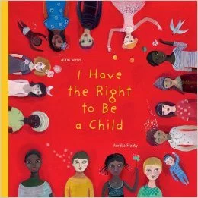
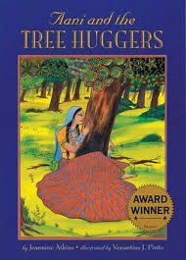
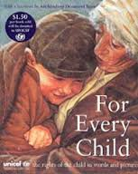

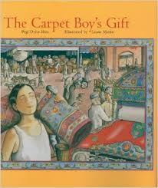
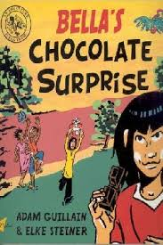
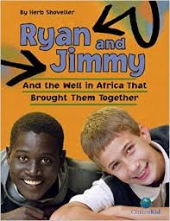
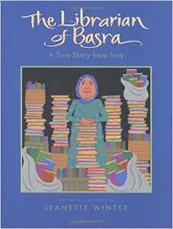

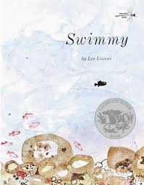

Technology Strategies
SMART Board
The SMART Board is used throughout this unit for students to interact with the unit information. Together as a class we can analyze the information and read through it for understanding. The benefit of the technology is that the students will be able to manipulate the information on the screen and it will be easily visible for all the students in the room to see.

KidPix or PowerPoint
These presentation programs will be used for students to demonstrate their knowledge and present their information in a different way. Students will have the opportunity to work with the technology and gain computer experience. Students will be able to enhance their presentations with visuals and even additional research. The use of these programs will depend on the availability of computers. Students may have to work in pairs or in small groups. If the computers are not available, the presentations can be done in a written format.

Assessment and Evaluation Tools
Unit Evaluation Criteria and Procedures

Anecdotal Records and Observation Notes - During each lesson students will be observed for participation and effort in the lesson activities. In order to understand the concepts the students need to be actively involved in the discussions and questioning process of the lesson activities. I will observe their ability to follow instructions and meet general classroom expectations, such as listening and respectful participation. These expectations help create a positive classroom environment conductive to learning. During the first few lessons I will focus on mentally noting the different abilities in the classroom throughout the lessons and afterwards make notes on the observations. Student responses to questions and as they work independently will be observed. These observation notes will be considered formative assessments of the students learning.

Questions to Check for Understanding - During or after most of the lessons, with an exception of a few, the students will be asked key questions. The key questions will guide the lesson objective for the day. I will monitor student responses to questions and attempt to pose questions that further deeper thinking. This will help me assess the students understanding of the material and help guide the learning that needs to happen next. The unit is designed with a theme of inquiry in mind. Students will be encouraged to develop their own meaning to the question of what it means to be a global citizen. Questioning will be used as an assessment tool throughout the unit to discover students pre-existing knowledge and to encourage students to think and dig deeper to answer their own questions.

Passport Journaling - The students will use “Passport Journals” to record the information and their interpretation of the information we are studying. These journals will be fitted to look like passports to fit with the theme of the unit. The journals will be in interactive format. In the interactive notebook, students record information in an engaging way. They actually become involved with the material by making charts, illustrating their notes, creating time lines, writing poetry, and stating their opinion. Doing this helps all students to demonstrate what they have learned and to remember that material. I will observe students as they work with their journals, and collect the journals throughout the unit to evaluate student’s progress. They will be used formatively throughout to guide instruction and learning, but will be taken in at the end of the unit to summatively assess students’ knowledge learned.
Checklists and Rubrics, including necessary criteria - The teacher will fill out a checklist with criteria based off of the lesson objectives and outcomes for presentation students will create. A rubric will be used to assess the work the students put into their journal. These assessment tools are included below.

Assessment Tools

Organization Presentation Checklist
✓ | Criteria
 | Named the organization
 | Described what work they do
 | Identified a right that the work relates to and why the right is important
 | Provide at least one reason to why they chose to support that organization

Passport Interactive Journals Rubric
 | 4 | 3 | 2 | 1
Understanding of Concepts | Demonstrates a thorough understanding of the subject matter | Demonstrates a general awareness of concepts | Demonstrates a limited awareness of concepts | Demonstrates a minimal understanding in discussion of concepts
Evidence of Thought and Creativity | Contains elaboration, extension, and/or evidence of higher-order thinking and connections to relevant prior knowledge | Some evidence of elaboration, extension, higher-order thinking, and connections to relevant prior knowledge | Limited evidence of elaboration, extension, higher-order thinking or connections to relevant prior knowledge | Little to no evidence of elaboration, extension, higher-order thinking, or connections to relevant prior knowledge
Use of Key Vocabulary | Strong use of vocabulary terms and concepts; defined terms in own words | Acceptable vocabulary use; majority of vocabulary terms defined | Simplistic vocabulary; few words defined | Inappropriate vocabulary for level
Effort | Student put exceptional effort into journal. Combination of words and drawings are included and goes beyond minimum expectations. | Student has put effort into journal. Combination of words and drawings are included; most details go beyond minimum expectations. | Student has put some effort into journal. Combination of words and drawings are included and details meet minimum expectations. | Student put little effort into journal. Very few words and drawings are included and few details meet minimum expectations.
Comments:

Resources and Websites Used
- Alberta Education. (2005). Connecting with the World. Don Mills, Canada: Pearson Education Canada.
Connecting with the World is the matching textbook for the Grade 3 social studies curriculum. The textbook is divided into four units that are titled Many Places, Many Lives, How Communities Work, Land and Resources, and Citizens of the World. The countries of focus are integrated into every chapter, with lots of visuals and easy to read text. The textbook will not be used directly in the unit, but is listed as a resource because information from it will be incorporated into activities and some of the tasks suggested will be adapted into the unit.
- http://www.e-activist.com/ea-campaign/action.retrievefile.do?ea_fileid=14113
- http://www.2learn.ca/kids/listSocG3.aspx?Type=6

- http://engagingstudents.blackgold.ca/index.php/division-i/soc-d1/social-studies-3/global-citizenship/

- http://www.activityvillage.co.uk/passport-for-kids

- http://craftyguides.blogspot.ca/2011/05/little-pretend-passports.html

- http://www.scholastic.com/teachers/book/swimmy#cart/cleanup

- http://www.nationalgeographic.com/kids-world-atlas/maps.html

- https://teachunicef.org/sites/default/files/documents/units-lesson-plans/global_citizenship_gr_3-5_final_7-13.pdf

- http://encyclopedia.kids.net.au/page/ca/Canadian_Charter_of_Rights_and_Freedoms

